- NCL Script is as below:
begin

a = addfile("/SPL3FTP.003_FT2015.nc", "r")
b = addfile("/20180101.nc", "r")

le1 = a->Freeze_Thaw_Retrieval_Data_Global_freeze_thaw(:,::-1,:,:)
le = le1(time|:, FakeDim2|:, lat|:, lon|:)
printVarSummary(le)
printMinMax(le, 1)

lat = b->lat
lon = b->lon

lon!0 = "lon"
lon@long_name = "longitude"
lon@units = "degrees_east"
lon&lon = lon
lat!0 = "lat"
lat@long_name = "latitude"
lat@units = "degrees_north"
lat&lat = lat

flh = linint2_Wrap(le&lon, le&lat, le, False, lon, lat,0)
printVarSummary(flh)
printMinMax(flh, 1)

flh@unit = "cm3/cm3"
flh@long_name = "Freeze-thaw"
time = ispan(0,dimsizes(le(:,0,0,0))-1, 1 )
time@units = "days since 2015-01-01"
flh!0 = "time"
flh&time = time
FakeDim2 = (/0,1/)
flh!1 = "FakeDim2"
flh&FakeDim2 = FakeDim2
flh!2 = "lat"
flh&lat = lat
flh!3 = "lon"
flh&lon = lon

dimNames = (/"time","FakeDim2","lat","lon"/)
dimSizes = (/dimsizes(flh(:,0,0,0)),dimsizes(FakeDim2),dimsizes(lat),dimsizes(lon)/)
dimUnlim = (/False,False,False,False/)

diroutt = "./"
filoutt = "sm_2015_ft_regridded.nc"

system("rm -f "+diroutt+filoutt)
foutt= addfile(diroutt+filoutt,"c")
setfileoption(foutt,"DefineMode",True)
filedimdef(foutt,dimNames,dimSizes,dimUnlim)

foutt->lat = lat
foutt->lon = lon
foutt->freezethaw = flh
end

- Script works and the following is the print summary of variable:
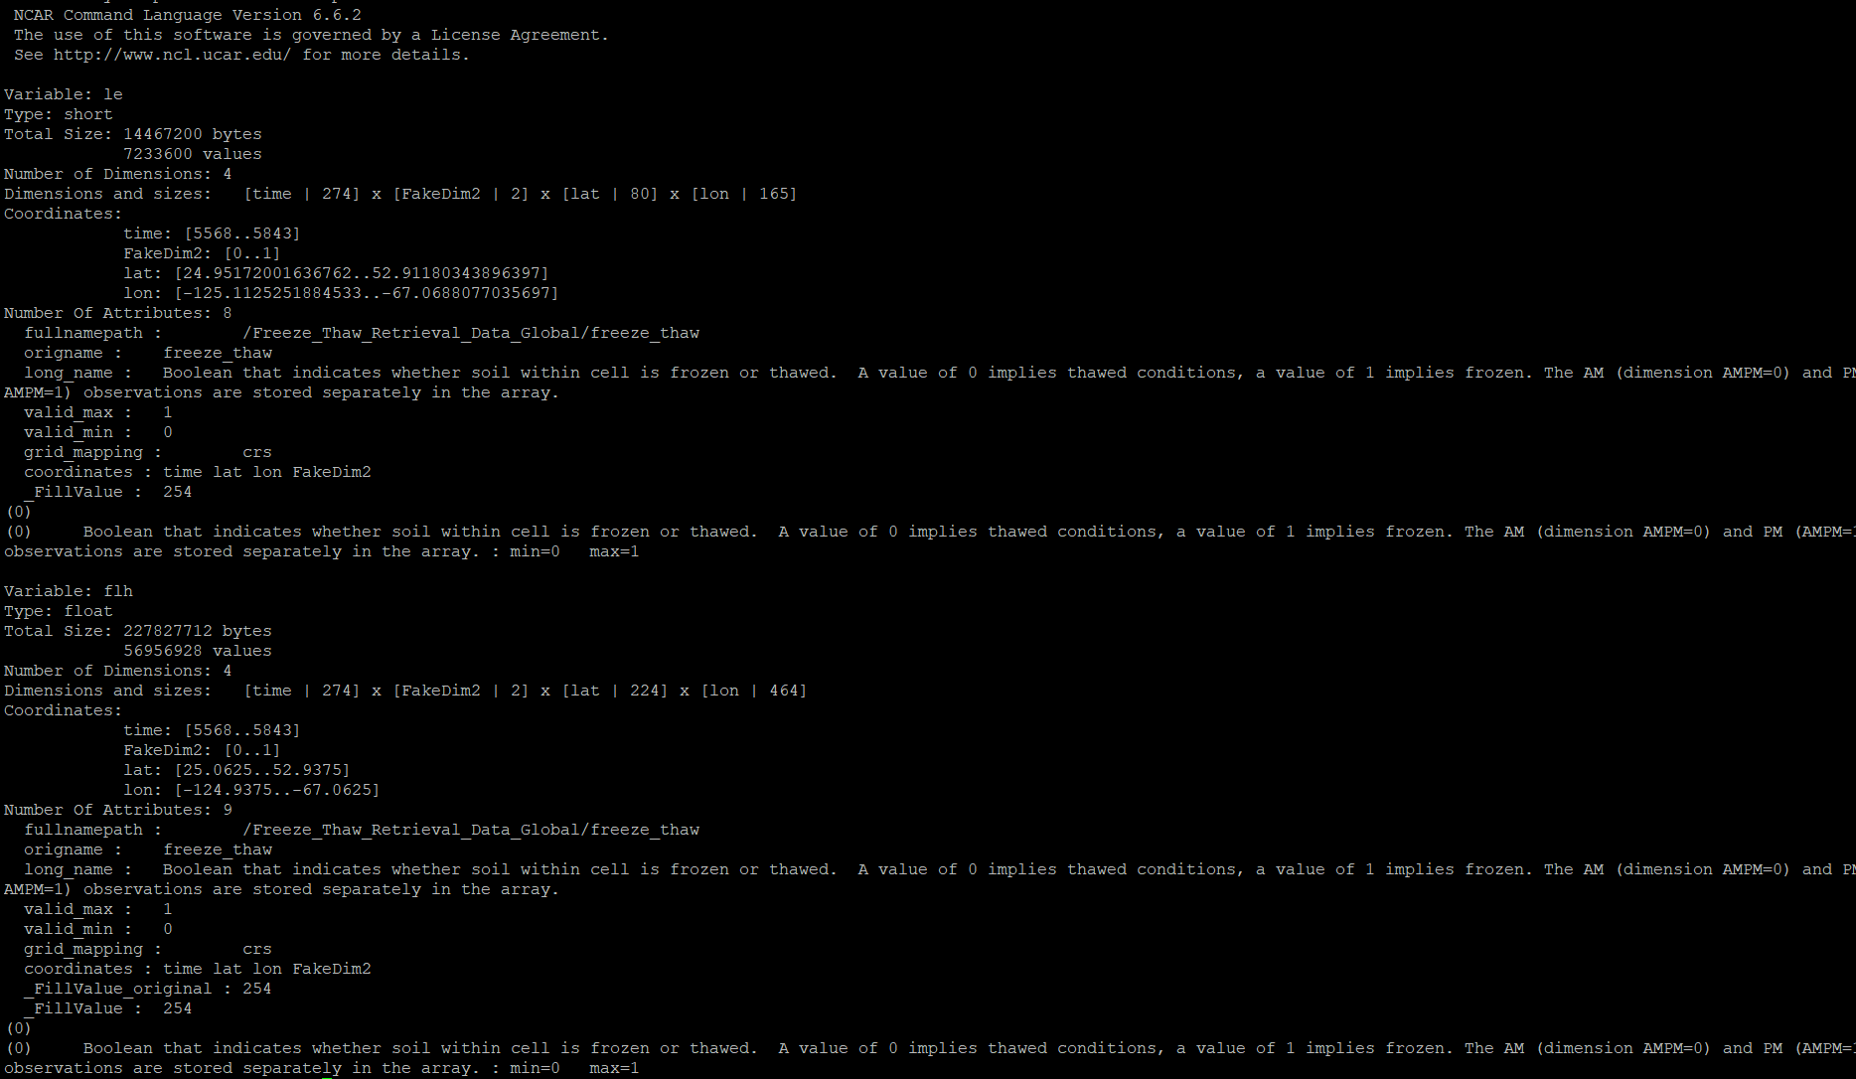

- The problem is that result of the output freeze thaw variable is not binary:
