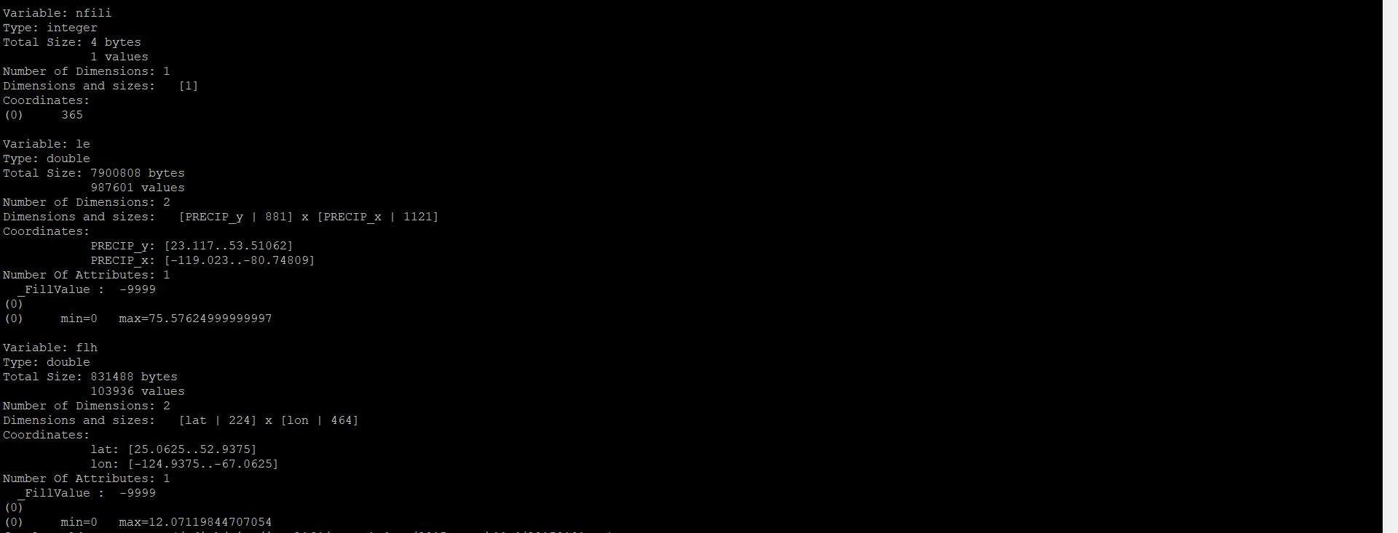
Error message is as below:
fatal:Could not create (./20150101.nc)
warning:FileSetFileOption: invalid file or format
fatal:["Execute.c":8637]:Execute: Error occurred at or near line 103 in file Regrid_stage4tonldas.ncl
Below is the ncdump of Stage-4 file that I want to regrid to make it to NLDAS grid:
Ncdump of file that I am trying to regrid the above file to -- NLDAS grid – NLDAS lat/lon

