Fully funded PhD Scholarship in Airborne Observations of Cloud Microphysics and Aerosol-Cloud Interactions over the Great Barrier Reef
Location: National Marine Science Centre, Southern Cross University, Coffs Harbour, Australia
Stipend: Tax-free PhD scholarship, generous travel support for fieldwork and conference attendance.
Start Date: Start as early as possible in 2026.
Background
One of the key areas of research and development at Southern Cross University focuses on exploring technologies to mitigate coral-bleaching stress by reducing the amount of solar radiation reaching the Reef. This involves investigating methods such as Marine Cloud Brightening (MCB) or fog generation to provide shade and lessen solar radiation during periods of heightened risk for coral bleaching. Our interventions range from reef-scale applications to strategies aimed at protecting the entirety of the Great Barrier Reef Marine Park. Through these efforts, we aim to pioneer effective solutions to preserve and enhance coral reefs' resilience to climate change.
We invite applications for a PhD position focused on airborne observations of cloud microphysical properties and aerosol-cloud interactions over the Great Barrier Reef (GBR), Australia. The successful candidate will analyse airborne measurements collected over the GBR using research aircraft. These measurements include in situ observations of aerosol and cloud microphysical properties as well as remote sensing observations of clouds and the underlying reef environment. The candidate will compare cloud systems influenced by artificially generated sea-salt aerosol plumes with unperturbed clouds to quantify aerosol-induced changes in droplet number concentration and size distributions, liquid water content, and cloud optical properties.
Project Summary
Marine Cloud Brightening is a proposed climate intervention technique that aims to enhance the reflectivity (albedo) of marine clouds by injecting sea-salt aerosol particles into the marine boundary layer. Understanding how injected aerosols influence atmospheric thermodynamics, cloud microphysical and radiative properties is essential for evaluating the feasibility and environmental impacts of this technique.
The project involves participation in airborne field campaigns over the Great Barrier Reef and includes analysis of data from aerosol and cloud probes and hyperspectral sensors. The research will focus on quantifying the microphysical response of marine clouds to aerosol perturbations and improving our understanding of aerosol-cloud interactions in the marine boundary layer.
Location
The successful candidate will be based in the National Marine Science Centre at Southern Cross University (Australia) with fieldwork taking place on the Great Barrier Reef (GBR). The Centre has a world-class research group with a multidisciplinary, collaborative and diverse team of post-graduate, post-doctoral and senior researchers. The candidate will also work within the collaborative Reefs and Oceans research cluster and have access to world-class facilities and infrastructure.
Selection Criteria:
- Excellent oral and written communication skills in English.
- Demonstrated ability to work effectively both independently and as part of a multidisciplinary research team.
- An undergraduate degree in atmospheric science, physics, remote sensing, or a related field.
- Strong quantitative and analytical skills with experience in scientific data analysis.
Desirable experience (not essential):
- Experience with modelling and programming (e.g., R, MATLAB, Python, IDL etc.).
- Experience with remote sensing data (hyperspectral or satellite datasets).
- Experience participating in field campaigns or environmental measurements.
- Experience in scientific writing or publishing.
Eligibility:
The successful applicant will need to meet the entry requirements to enrol in a PhD at Southern Cross University on a full-time basis.
The successful candidate will receive a PhD stipend at the RTP rate of AU$33,511 per annum (2025 rate indexed annually) for 3 years and 3 months. Tuition fees will be exempt and the successful candidate will need to meet the entry requirements to enrol in a PhD at Southern Cross University on a full-time basis.
This opportunity is open to International as well as Australian Domestic students. Applicants whose first language is not English are also required to meet English Language Proficiency requirements (an International English Language Test Score (IELTS) Academic (or equivalent) equal to or above 7.0, with a minimum 7.0 in writing and no other band less than 6.5.
How to apply
Please send one PDF file to ramon.braga@scu.edu.au containing:
- Cover letter describing research interests, plans, and qualifications for this scholarship (1 page max).
- Curriculum vitae (2 pages max).
- Relevant degree transcripts/certificates.
- The names and contact information of two references.
Please use the subject line ‘PhD Application – Airborne Observations of Cloud Microphysics’. Applications will be reviewed on a rolling basis starting 16 March 2026 until the position is filled.
Invitation to attend an interview
If your application is shortlisted, you will be invited to attend an interview. Further details about the interview will be provided in the invitation. Applications will be assessed on an ongoing basis until the role is filled. We hope to commence this position as soon as possible.
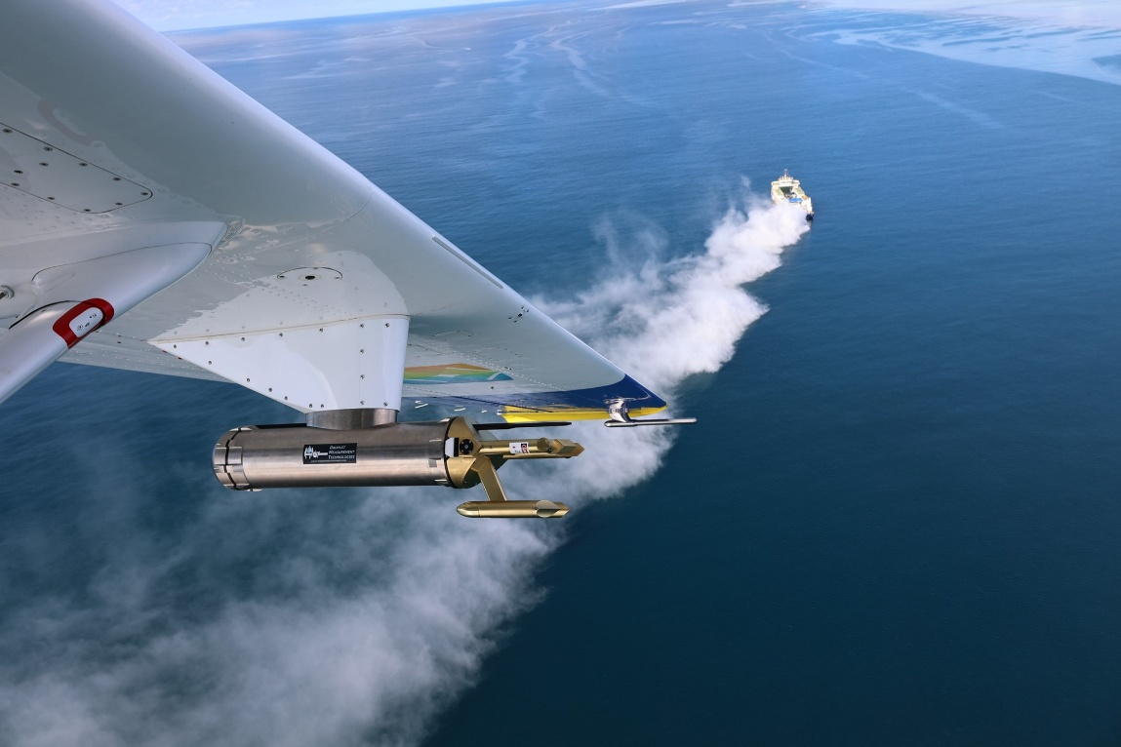
Photo taken from the aircraft cockpit during a Marine Cloud Brightening field campaign.

