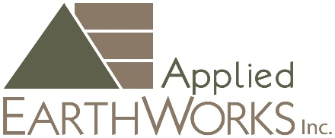

PRINCIPAL PALEONTOLOGIST
Paleontological and project management leader in an environmental compliance setting equally capable in both deliverable authorship and review.
See full job posting on our website: https://www.appliedearthworks.com/principal-paleontologist
Location: Pasadena, CA
Applied EarthWorks, Inc. (Æ) has an immediate opening a full-time Principal Paleontologist, ideally in our Pasadena, CA office with some flexibility for a hybrid schedule. This position reports to and works closely with Æ’s Paleontology Program Manager.
Pay Range:
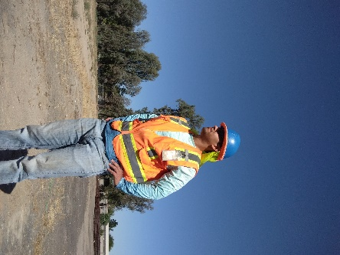
Principal $90,000 - $105,000 annually/DOE

Duties:
The Principal directs the largest and most complex paleontological resource projects, working closely with other staff maintaining awareness and a highly collaborative approach with all disciplines throughout the company.
The Principal Paleontologist manages the day to day efforts of Æ’s Paleontology Program, supporting Senior Paleontologists overseeing technical specifications and ensuring the accuracy and timeliness of teams executing work; preparing scopes of work and budgets to ensure they properly align services with project needs and meet/exceed best management practices; preparing or reviewing technical reports, management plans, and other compliance documents; prepare and present annual Paleontology Program training materials; oversee proactive tracking of project status, resources, and priorities for projects; anticipate client and project needs; troubleshoot; and assist/mentor/coach junior paleontological and cross-trained staff.

Additionally, the Principal Paleontologist will manage client and agency relationships; maintain current regulatory expertise; mentor staff; advise staff as they design and complete projects; perform high-level QA/QC reviews to ensure that work products meet the company’s technical, regulatory, professional, and scholarly standards across all disciplines; source marketing and new business development opportunities; and represent the company in business and professional activities.

Skill Requirements:

- Manage and direct complex paleontological fieldwork, lab processing and analysis, and preparation of technical reports.
- Supervise, mentor, and manage all paleontology staff levels.
- Manage personnel, project and office schedules.
- Adapt quickly to changes in project needs.
- Review RFPs and contracts and identify potential pitfalls; negotiate agreement documents.
- Make sound bid/no-bid decisions promptly and prepare complex scopes of work and budgets.
- Develop work for staff, keeping the pipeline of upcoming projects full.
- Utilize excellent technical writing skills with a record of completing technical reports timely and within budgets.
- Complete QA/QC report reviews and edits.
- Thoroughly understand the CEQA, NEPA, PRPA, and other laws and regulations governing paleontological resource management.
- Ability and desire to publish and present findings in professional and public-outreach settings.
- Work independently and collaboratively with a variety of colleagues, clients, agency and tribal representatives, construction contractors, and other project stakeholders and resolve conflicts when they arise.
- Excellent communication, follow up, and other interpersonal skills necessary to successfully perform throughout all levels of the business.

Education and Experience:
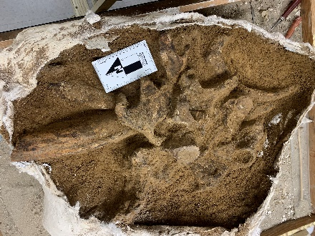
Must meet industry-wide and federal qualification standards for Principal Investigator/Project Paleontologist/Field Director; Society of Vertebrate Paleontology (SVP) qualifications are welcome but not mandatory. Candidates must have:
- Advanced degree in geology, paleontology, biology, or related field.
- Minimum of 12 years of progressively responsible employment in paleontological resource management which includes demonstrated project and/or program management experience.
- Prior experience in California is preferred.

  - Preference will be given to candidates with significant demonstrated knowledge, skills, and abilities in paleontological and project management experience in an environmental compliance setting including successful authorship of past CEQA and/or NEPA documents.

How to Apply:
Apply online.
Interested applicants may submit a letter of interest, resume/curriculum vitae, a technical writing sample and list of three professional references to Human Resources at info@appliedearthworks.com. Please reference “Principal Paleontologist” in the subject line. No phone calls please.
Salary Equity and Transparency - Æ is committed to salary equity and salary transparency for all employees. We include good faith pay ranges in all advertised job postings to promote pay equity and transparency.
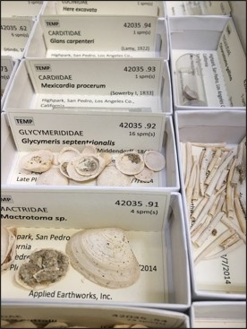
An employee in this CA-based position can expect a salary of $90,000-$105,000/year for the Principal Paleontologist position. Actual pay within this range may depend on experience, qualifications, geographic location, client requirements where applicable, and other factors permitted by law. Candidates are also encouraged to consider Æ’s total compensation package including competitive benefits, ESOP participation, professional development, exclusive in-house leadership development and coaching.

Æ diversity, equity & inclusion pledge
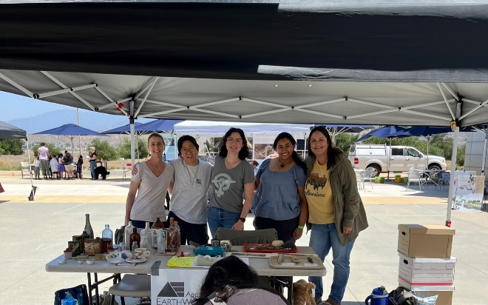
As members of our local communities, Æ's employee owners strive to promote diversity, equity, and inclusion (DEI) in the field of Cultural Resource Management (CRM). We raise awareness to our communities through outreach and learning opportunities increasing exposure to CRM, archaeology, and paleontology. We help overcome barriers to entry into the field, such as offering professional development time, tuition reimbursement, and potential field school scholarships. We invest in educational opportunities to serve and educate others appropriately and effectively. Finally, we offer internal tools for our staff communicating DEI content and events.
Æ is an equal opportunity employer. All qualified applicants will receive consideration for employment without regard to age, ancestry, color, disability (mental or physical), gender identity or expression, genetic information, marital status, medical condition, military veteran status, national origin, political affiliation, pregnancy, race, religion or creed, sex, sexual orientation, or any other factor that is not related to the job. Women, minorities, individuals with disabilities and veterans are encouraged to apply.

