Postdoctoral Scholar Position Opening – Northern Arizona University

Looking for a postdoc position? Interested in vegetation phenology? Multi-factor global change experiments? Land-atmosphere interactions? PhenoCams and near-surface remote sensing? Quantitative modeling?

The Richardson Lab at Northern Arizona University, in beautiful Flagstaff, Arizona, has an opening for a postdoctoral researcher to work on these topics! The successful candidate will conduct modeling and analysis of phenological data from the SPRUCE experiment (https://mnspruce.ornl.gov/) run by DOE’s Oak Ridge National Lab (ORNL) in northern Minnesota. The successful candidate will primarily work with PhenoCam (http://phenocam.nau.edu) data and imagery from the site, supplemented with ground observations collected by SPRUCE technicians. Analyses will focus on the role of elevated temperature and CO2 treatments on (1) spring and autumn phenology of common boreal peatland tree and shrub species, and (2) land-atmosphere feedbacks and interactions.

Questions? Contact Andrew Richardson (andrew.richardson@nau.edu).

Applicants must be willing to work collaboratively on team projects. The Richardson lab is based in the Center for Ecosystem Science and Society (Ecoss) and the School of Informatics, Computing, and Cyber Systems (SICCS). The Postdoctoral Scholar will interact regularly with SPRUCE collaborators at ORNL and the USDA Forest Service.

The Postdoctoral Scholar will be based in Flagstaff; occasional travel to the field site in Minnesota may be necessary. Applications should be received by November 25, 2023 to receive full consideration. The start date is negotiable, but early 2023 is preferred.

Flagstaff is a small city of 75,000 residents, located at 7000’ on the southern edge of the Colorado Plateau and the foot of the 12,500’ San Francisco Peaks. There are abundant opportunities for outdoor recreation within a 45 minute drive of Flagstaff, from hiking and climbing to downhill and Nordic skiing, and the Grand Canyon is less than 90 minutes away.

Northern Arizona University is a committed Equal Opportunity/Affirmative Action Institution. Women, minorities, veterans and individuals with disabilities are encouraged to apply.

Please note that all applications must be submitted through the NAU HR web page, https://in.nau.edu/human-resources/. To apply:

1. Select the link to access the NAU careers site.
2. Sign In to access your account or if you are not an existing user select the New User link to create one.
3. Review the job description (position 607447) and select the Apply button to begin your application.

https://hr.peoplesoft.nau.edu/psp/ph92prta/EMPLOYEE/HRMS/c/HRS_HRAM.HRS_APP_SCHJOB.GBL?Page=HRS_APP_JBPST&Action=U&FOCUS=Applicant&SiteId=1&JobOpeningId=607447&PostingSeq=1

The Center for Ecosystem Science and Society is housed on the top floor of the building on the left; the San Francisco Peaks can be seen in the distance.

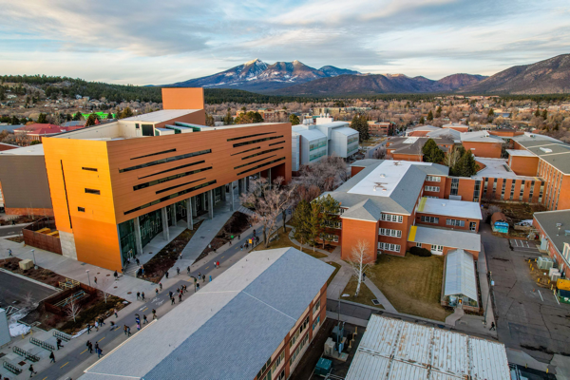

Enclosures like these are used to apply experimental warming and eCO2 treatments at the SPRUCE experiment in Minnesota

