Research Associate (2 positions)

The Atmospheric Sciences Research Center (ASRC) of the University at Albany, State University of New York, seeks to hire two permanent-eligible (equivalent to tenure track) Research Associates in the Atmospheric Sciences. Areas of particular interest include, but are not limited to, Atmospheric Chemistry and Air Quality, Flood Hydrology, Radar Meteorology, and Climate. Experience in AI applications is favored.

The successful candidates will be expected to pursue and secure funding to support a robust research program and publish their work in academic (e.g. scientific peer-reviewed) journals. We expect the position to strengthen ASRC and the University by (i) maintaining a strong externally funded research program, (ii) mentoring graduate students and postdocs, and (iii) participating, as necessary, in service to the Center and the University.

ASRC has access to resources from a number of facilities, including:
- Whiteface Mountain
- ASRC Mobile Laboratory
- xCite Lab
- Center of Excellence
- NYS Mesonet
- DAES Facilities

ASRC also maintains collaborative relationships across UAlbany departments and NY agencies
- College of Emergency Preparedness, Homeland Security, and Cybersecurity (CEHC)
- Geography & Planning
- Environmental & Sustainable Engineering
- Environmental Health Sciences
- Chemistry
- NYS DEC

ASRC’s new home is ETEC. This state-of-the-art facility features excellent laboratory and teaching facilities and offers rich new opportunities for collaboration and innovation.
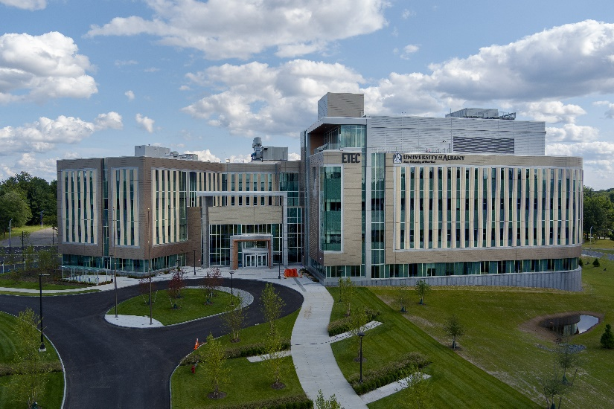
[Photo: ETEC]

ASRC fully supports diversity and inclusion. We strive to support the recruitment and retention of a diverse population of staff, students, and research scientists within the Center. We work to share our science with diverse audiences locally, nationally, and globally. We strive to foster an environment that is inclusive, welcoming, and respectful to all. Applicants must address in their application their ability to work with and instruct a culturally diverse population.

Qualified candidates should submit a cover letter, a detailed curriculum vitae, a statement of research interests and the names and contact information of three references through Interview Exchange at: https://albany.interviewexchange.com/candapply.jsp?JOBID=158006#pageTop.

For more information about this announcement, including deadlines and required documents, please refer to the Human Resources website at ASRC Research Associates (2 positions) or contact Sara Lance (slance@albany.edu, 518-437-8663).

A review of applications will start on March 1, 2023 and the posting will remain open until the position is filled.

The University at Albany is an EO/AA/IRCA/ADA Employer.

