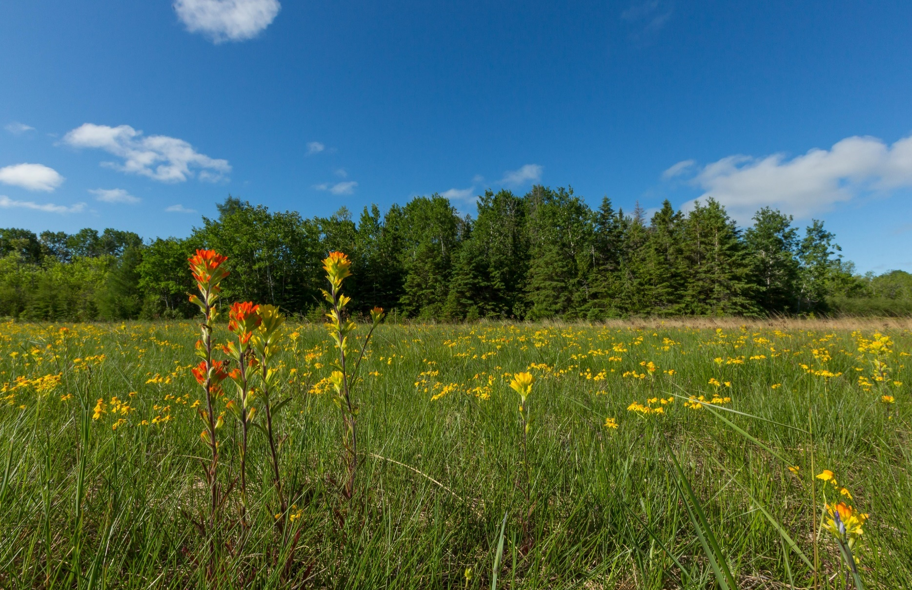

The Nature Conservancy
Land and Water Protection Associate
Position Number: 52247
Photo credit: © Jason Whalen/Fauna Creative

Become a force for nature and a healthy planet by joining the Michigan team!

ABOUT THE NATURE CONSERVANCY:

The Nature Conservancy (TNC) is a global conservation organization dedicated to conserving the lands and waters on which all life depends. Working in 76 countries and territories, including all 50 U.S. states, we use a collaborative approach that engages local communities, governments, the private sector, and other partners. To learn more, visit www.nature.org.

Grounded in our mission and guided by our values — which include a commitment to diversity and a respect for people, communities, and cultures — we at TNC can only achieve our mission with a workforce that reflects the communities in which we work. We strive to cultivate an inclusive work environment in which all our colleagues around the world feel safe, welcome, and valued for their unique talents and contributions. TNC’s Michigan Chapter offers competitive compensation, excellent benefits, a 401 (k) retirement plan with employer matching contribution for eligible employees, and a collaborative and dynamic work environment. Whether it’s career development, work/life balance, or a rewarding mission, there are lots of reasons to love life at TNC.

YOUR POSITION WITH TNC:

The Nature Conservancy in Michigan remains dedicated to protecting the lands and waters of the state through a variety of protection mechanisms. The Land and Water Protection Associate will directly support The Conservancy’s conservation efforts by developing, maintaining, and managing the essential ecological, social, and legal information that is necessary to execute our conservation mission. Specifically, the Land and Water Protection Associate manages and maintains conservation, legal record, and compliance databases and provides technical support in GIS or other relational database technologies to Conservancy staff. This position provides support, technical writing for grant and project approvals, and completes due diligence for protection and real estate activities. The compensation range begins at $53,000 and is dependent upon experience.

MINIMUM QUALIFICATIONS

- MS or BS degree and certification in related field and 3 years related experience, or equivalent combination of education and experience.
- Experience managing, maintaining, and populating databases and manual files.
- Experience with interpretation of image analysis, complex spatial analysis, data modeling and landscape scenario analysis.
- Experience managing multiple projects.
- Experience operating GIS software, analyzing data and producing data reports and creating maps.
- Experience interpreting results then developing and delivering training (if required) to practitioners.
- Experience with Microsoft Word, Excel, Access.
DESIRED QUALIFICATIONS

- 3-5 years related experience or equivalent combination of education and experience.
- Working knowledge of legal real estate documents.
- Geographic, landform, and ecological technical writing experience.
- Experience with database queries, reporting and output.
- Knowledge of current trends and practices in relevant discipline(s) and geographic region(s).
- Experience collaborating with other parties to obtain different data sources.
- Managing and prioritizing tasks from multiple sources and meeting deadlines.
- Communicating clearly via written, spoken, and graphical means in English and other relevant languages.

HOW TO APPLY:

See full job description and apply with cover letter and resume at www.nature.org/careers. Search for
Job ID 52247 Deadline to apply is 11:59PM EST, October 24th , 2022.

The Nature Conservancy is an Equal Opportunity Employer.
Our commitment to diversity includes the recognition that our conservation mission is best advanced by the leadership and contributions of people of all genders, diverse backgrounds, beliefs, and culture. Recruiting and mentoring staff to create an inclusive organization that reflects our global character is a priority, and we encourage applicants from all cultures, races, colors, religions, sexes, national or regional origins, ages, disability status, sexual orientation, gender identity, military, protected veteran status or other status protected by law.

