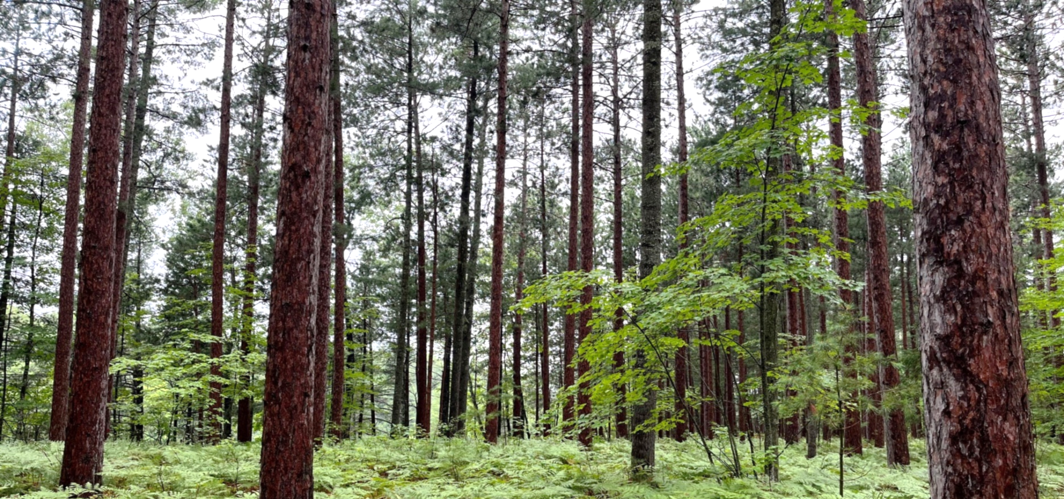

The Nature Conservancy
Project Manager, Forest and Climate Conservation
Position Number: 52080

Who We Are:

The Nature Conservancy’s mission is to protect the lands and waters upon which all life depends. As a science-based organization, we create innovative, on-the-ground solutions to our world’s toughest challenges so that we can create a world in which people and nature thrive. We’re rooted in our Mission and guided by our Values, which includes a Commitment to Diversity and Respect for People, Communities, and Cultures. Whether it’s career development, flexible schedules, or a rewarding mission, there’s lots of reasons to love life #insideTNC. Want a better insight to TNC? Check out our TNC Talent playlist on YouTube on Glassdoor.

Our goal is to cultivate an inclusive work environment so that all our colleagues around the globe feel a sense of belonging, and that their unique contributions to our mission are valued. We’ll only achieve our Mission by hiring and engaging a diverse workforce that reflects the communities in which we work. In addition to the requirements in our postings, we recognize that people come with talent and experiences outside of a job. Diversity of experience and skills combined with passion is a key to innovation and a culture of inclusion! Please apply – we’d love to hear from you. To quote myriad TNC staff members, “you’ll join for our mission, and you’ll stay for our people.”

What We Can Achieve Together:

The Project Manager, Forest and Climate Conservation will be based out of Marquette, MI, and will be a member of the Conserving Resilient Lands and Waters team. Duties will include conservation planning and management of the Michigan Business Unit’s Natural Climate Solutions and Forestry Strategies with the goal of improving forest health and resiliency and sequestering and storing more carbon. It will also include oversight of forestry related restoration projects on TNC, private, or partner lands to meet Michigan, Midwest, and North America goals and objectives.
This position will oversee planning and implementation of our Forest, Natural Climate Solutions, and Northwoods conservation strategies where they touch down in Michigan including protecting resilient, connected and climate adapted corridors, advancing natural climate solutions, improving forest health through partnerships, sustaining forest product markets, and disseminating forest climate science. The Project Manager, Forest and Climate Conservation will work with multiple partners, private and industrial landowners to accomplish Michigan’s goals associated with TNC’s 2030 goals. They will build strategic, scientific, and technical capacity around sustainable forestry practices, forest carbon sequestration and storage, climate resiliency, and carbon markets.
The Project Manager, Forest and Climate Conservation will implement and manage the Michigan Business Unit’s Conserving Resilient Land and Water’s Forest Strategy by:
- Overseeing carbon mitigation, adaptation, and restoration work in Michigan’s forests and providing technical input for forestry-related management activities on TNC preserves, and on private and partner lands through various programs, agreements, and contracts.
- Leading carbon project enrollment and assisting with carbon project and land deals related to the Forest Strategy, on TNC land, or for partners, private or industrial landowners, and assist with project related documentation, contracts with developers, and documenting and receiving approvals through the Carbon Project Review Committee with the Director of Land Protection.
- Managing projects that support Natural Climate Solution practices on private forest land across the Northwoods (Michigan, Wisconsin, and Minnesota) including but not limited to Family Forest Carbon Program
- Negotiating and overseeing the management of multiple large forest adaptation and management related restoration grant agreements with the USDA Forest Service, the State of Michigan, and other partners.
- Contributing to larger TNC Forest and Climate goals by participating as a member of the Northwoods, U.S. Forest Carbon, and U.S. Forest Policy teams.
- Fostering partnerships in the working forest landscape with Federal, State, Tribes, Land Trusts, and industrial and private forest landowners.
The Project Manager, Forest and Climate Conservation, will also supervise two positions that are focused on: 1) executing multiple agreements with the Forest Service and Partners designed to increase the pace and scale of forest and water restoration in Michigan and Wisconsin, and 2) executing forestry-related, infrastructure and property management activities on TNC’s Forest Reserves that total 47,000 acres.
Essential Position Functions include:
- Manage multi-disciplinary administrative and professional staff, with responsibility for performance management, training and career development.
- Gain cooperation from outside parties to accomplish program goals.
- Produce and organize written documentation relevant to strategies, projects, and legal compliance.
- Develop and implement forest strategies that mitigate, restore and promote biodiversity benefits.
- Financial responsibility may include working within/managing a budget to complete projects, negotiating, and contracting with vendors, assisting with budget development, and meeting fundraising targets.
- Ensures program compliance with internal policies and external requirements.
- Under minimal supervision, makes independent decisions based on analysis, experience, and context.
- May work in variable weather conditions, at remote locations, on difficult and hazardous terrain and under physically demanding circumstances.
We’re Looking for You:

Want to help save the planet? Through the efforts of The Nature Conservancy, over 60,000 acres in Michigan have been preserved for people and nature. From the mountains to the sea, the Michigan Chapter is dedicated to conserving the natural resources that make Michigan unique. This is an exceptional career opportunity for a highly motivated, capable individual interested in joining the world’s leading conservation organization!

This position will report to the Director of Land and Water Management, will be based out of Michigan’s Upper Peninsula. The compensation range begins at $60,000 and is commensurate with skills and experience.

What You’ll Bring:

MINIMUM QUALIFICATIONS
- BA/BS degree in forestry, natural resource management, ecology, environmental science or related field and 5 years’ experience in conservation practice or equivalent combination of education and experience.
- Experience managing complex or multiple projects, including staffing, workloads, and finances under deadlines.
- Supervisory experience, including motivating, leading, setting objectives, and managing performance.
- Experience in partnership development with non-profit partners, community groups, and/or government agencies.
- Experience negotiating.

DESIRED QUALIFICATIONS
- Multi-lingual skills and multi-cultural or cross-cultural experience appreciated.
- Knowledge of land management conservation practice and conservation science.
- Degree and experience in forestry, natural resource management, similar field or equivalent combination of education and experience.
- Project management experience.
- Experience managing forestry activities, including contracts, knowledge of carbon projects/programs/methodologies, timber harvests, forest inventory.
- Experience in Forest Restoration and Adaptation project management and techniques
- Knowledge of and willingness to participate in professional forester groups in Michigan.
- Technical report and grant proposal writing experience appreciated.
- Ability to communicate conservation practices to technical and non-technical audiences both written and verbally.
- Knowledge of current trends and practices in conservation, land management, and natural resource preservation.
- Familiarity with principles of land acquisition, protection, and acquiring conservation and other legal interests in property.
- Completing tasks independently with respect to timeline(s).
- Excellent communication skills via written, spoken and graphical means in English and other relevant languages.

What We Bring:

Since 1951, The Nature Conservancy has been doing work you can believe in protecting the lands and waters that all life depends on. Through grassroots action, TNC has grown to become one of the most effective and wide-reaching environmental organizations in the world. Thanks to more than 1 million members, over 400 scientists, and the dedicated efforts of our diverse staff, we impact conservation throughout the world!

The Nature Conservancy offers a competitive, comprehensive benefits package including: health care benefits, flexible spending accounts, 401(k) plan including employer match, parental leave, accrued paid time off, life insurance, disability coverage, employee assistance program, other life and work wellbeing benefits. Learn more about our benefits at in the Culture Tab on nature.org/careers.

We’re proud to offer a work-environment that is supportive of the health, wellbeing, and flexibility needs of the people we employ!

See full job description and apply with cover letter and resume at www.nature.org/careers. Search for
Job ID 52080. Deadline to apply is 11:59PM EST, September 22nd, 2022.

Our Competencies:

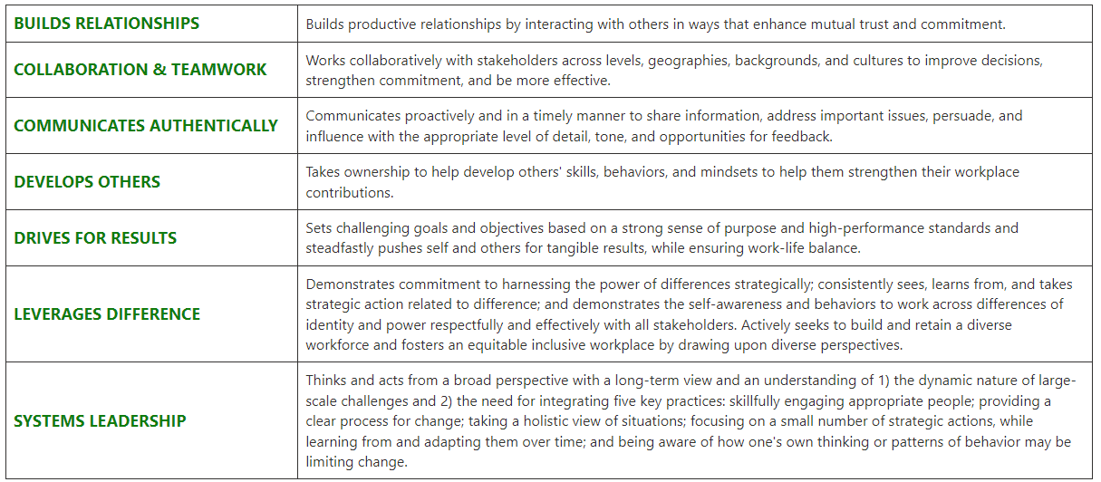
The Nature Conservancy is an Equal Opportunity Employer. Our commitment to diversity includes the recognition that our conservation mission is best advanced by the leadership and contributions of people of diverse backgrounds, beliefs, and cultures. Recruiting and mentoring staff to create an inclusive organization that reflects our global character is a priority and we encourage applicants from all cultures, races, colors, religions, sexes, national or regional origins, ages, disability status, sexual orientations, gender identities, military, protected veteran status or other status protected by law.
TNC is committed to offering accommodations for qualified individuals with disabilities and disabled veterans in our job application process. If you need assistance or an accommodation due to a disability, please send a note to applyhelp@tnc.org with Request for Accommodation in the subject line.

