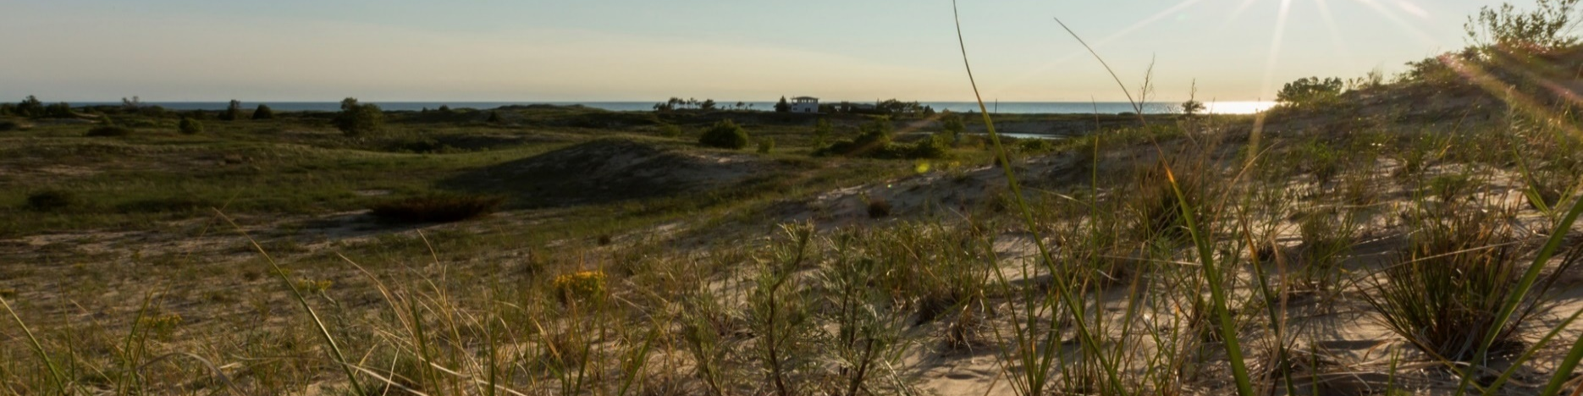

The Nature Conservancy
Associate Director, Conservation Programs
Position Number: 52111

Photo credit: © Fauna Creative

Become a force for nature and a healthy planet by joining the Michigan team!

Who We Are:

The Nature Conservancy’s mission is to protect the lands and waters upon which all life depends. As a science-based organization, we create innovative, on-the-ground solutions to our world’s toughest challenges so that we can create a world in which people and nature thrive. We’re rooted in our Mission and guided by our Values, which includes a Commitment to Diversity and Respect for People, Communities, and Cultures. Whether it’s career development, flexible schedules, or a rewarding mission, there’s lots of reasons to love life #insideTNC. Want a better insight to TNC? Check out our TNC Talent playlist on YouTube on Glassdoor.

Our goal is to cultivate an inclusive work environment so that all our colleagues around the globe feel a sense of belonging, and that their unique contributions to our mission are valued. We’ll only achieve our Mission by hiring and engaging a diverse workforce that reflects the communities in which we work. In addition to the requirements in our postings, we recognize that people come with talent and experiences outside of a job. Diversity of experience and skills combined with passion is a key to innovation and a culture of inclusion! Please apply – we’d love to hear from you. To quote myriad TNC staff members, “you’ll join for our mission, and you’ll stay for our people.”

What We Can Achieve Together:

The Michigan chapter of TNC has a conservation team of over 35 professionals developing and implementing innovative strategies designed to conserve freshwater, forest and coastal habitats as well as mitigate and address the impacts of climate change. This work is accomplished in collaboration with our Midwest Division colleagues and chapters with the aim of scaling up our impact and achieving our division’s maximum contribution to TNC’s 2030 goals. To help advance the strategies, the Associate Director, Conservation Programs provides subject-matter, management and systems support for the conservation department. Importantly, the Associate Director will bring an expansive view of the discipline of conservation that includes science, policy and finance combined with project management skills, as well as understanding issues of diversity, equity, inclusion, and justice in the advancement of conservation outcomes.
The Associate Director, Conservation Programs will apply a deep understanding of conservation strategies, initiatives, and planning, along with a clear understanding of how to efficiently and effectively operate in a matrix-management enterprise to achieve goals. In collaboration with the Associate State Director and the Conservation Management Team, they are integral to the effectiveness of the Conservation department by supporting the development and implementation of conservation strategies, helping to overcome hurdles to delivery and improving workflows and communications within the department and with other chapter functions. The Associate Director may lead and manage staff that support conservation efforts.
Conservation Strategy Management. The Associate Director will: 1) support eight to ten strategy teams in the development of conservation strategies and measures that align with The Nature Conservancy’s mission and 2030 goals, 2) direct annual strategy reviews to evaluate progress, improve conservation efforts and prioritize work, and 3) lead strategy audits for a thorough evaluation of strategy effectiveness applying TNC methodologies and tools. Additionally, this position will assist strategy teams in adaptive management of strategies and projects.
Conservation Program Implementation. This position will: 1) facilitate cross-organization strategy and program implementation in collaboration with the Associate State Director, 2) lead chapter use of TNCs Conservation Hub, a project management database, for tracking progress towards conservation outcomes, 3) develop dashboards and reports to assist with execution, communication, and adaptive management, and 4) proactively support, resolve, or elevate issues to conservation management team. This position will also oversee a variety of reporting mechanisms designed to share program progress, plan for upcoming milestones, and facilitate coordination and communication between organizational functions.
Conservation Operations. The Associate Director will oversee the annual planning cycle that is comprised of budgeting, developing annual work plans, identifying key milestones and measures of success for the year and managing strategic plan documentation updates. As a member of the Conservation Management Team, this position will participate in planning and decision making that support achievement of conservation goals. Additionally, they will be responsible for 1) adhering to standard operating processes and procedures that underpin the successful planning and execution of conservation projects, 2) disseminating best practices, and providing training and analyses to improve effectiveness and efficiency, and 3) assisting the Associate State Director with managing the conservation department budget and approvals on agreements, proposals, and external communications. Finally, the Associate Director, Conservation Programs will supervise and develop Conservation Operations staff.
We’re Looking for You:

Are you looking for a career to help people and nature? Guided by science, TNC creates innovative, on-the-ground solutions to our world’s toughest challenges so that people and nature can thrive together.

We’re looking for someone who is passionate, motivated problem-solver. Responsibilities include:

- Works within a larger, complex business unit and/or a program that requires cross-boundary work and relationships.
- Frequently makes independent strategic decision based on analysis, ambiguous information, and context.
- Collaborates with TNC colleagues outside of Michigan in the development or implementation of operating standards related to portfolio management, use of the Conservation Hub to track progress toward conservation goals, management reporting and other points of intersect between the chapters and the division.
- Provides leadership to the program coordinator team to ensure delivery of high-quality support across conservation strategies.
- Works with conservation staff and other department directors to streamline the flow of information and collectively problem solve to improve processes and communications.
- May be responsible for leading special projects to address areas of improvement or better respond to needs of larger organization.
- May participate in internal or external technical work groups and committees to contribute to development of conservation or operational methods, tools, and guidance.
- Assists strategy teams in identifying sources of public funding and developing proposals.
- Supervise and develop staff.
- Establishes and maintains optimal performance standards within budget.
- Negotiates complex agreements, in a political environment.
- Some travel will be required to facilitate program management and cross-program collaboration as well as occasional evening and weekend hours.
- May work in variable weather conditions, at remote locations, on difficult and hazardous terrain, and under physically demanding circumstances.

The compensation range for this position begins at $87,000 and is commensurate with skills and experience.

What You’ll Bring:

MINIMUM QUALIFICATIONS

- BA/BS degree and 7 years’ experience in conservation practice or related field or equivalent combination of education and experience.
- Experience developing program-wide operating procedures and guidelines for successful implementation.
- Experience with public or private fundraising.
- Experience managing complex or multiple projects, including managing databases, finances and coordinating the work of other professionals and partners.
- Supervisory experience, including motivating, leading, setting objectives and managing performance.
- Experience in partnership development with non-profit partners, community groups and/or government agencies.
- Experience negotiating.

DESIRED QUALIFICATIONS

- 7-10 years’ experience in conservation practices, science, environmental policy or equivalent combination of education and experience.
- Demonstrated experience influencing, developing and implementing conservation policy and plans.
- Knowledge of current trends and practices in relevant discipline(s) and regions, including policy, finance, and science.
- Understanding the policy implications, opportunities, and challenges of conservation strategies.
- Ability to develop practical applications of scientific concepts and technical innovations for conservation purposes.
- Knowledge of methods and standards of biodiversity information systems and initiatives or related field.
- Experience with integrating dimensions of diversity, equity, inclusion, and justice in conservation planning and/or implementation.
- Ability to work well in a highly matrixed, decentralized, and collaborative organization. Must be a team player.
- Knowledge of adaptive management methods and practices, including ability to facilitate and guide team discussions productively.
- Ability to manage and influence without direct authority.
- Communicating clearly via written, spoken, and graphical means.
- Multi-lingual and multi-cultural or cross-cultural experience appreciated.

What We Bring:

Since 1951, The Nature Conservancy has been doing work you can believe in protecting the lands and waters that all life depends on. Through grassroots action, TNC has grown to become one of the most effective and wide-reaching environmental organizations in the world. Thanks to more than 1 million members, over 400 scientists, and the dedicated efforts of our diverse staff, we impact conservation throughout the world!

The Nature Conservancy offers a competitive, comprehensive benefits package including health care benefits, flexible spending accounts, 401(k) plan including employer match, parental leave, accrued paid time off, life insurance, disability coverage, employee assistance program, other life and work wellbeing benefits. Learn more about our benefits at in the Culture Tab on nature.org/careers.

We’re proud to offer a work-environment that is supportive of the health, wellbeing, and flexibility needs of the people we employ!

See full job description and apply with cover letter and resume at www.nature.org/careers. Search for
Job ID 52111. Deadline to apply is 11:59PM EST, September 29th, 2022.

Our Competencies:

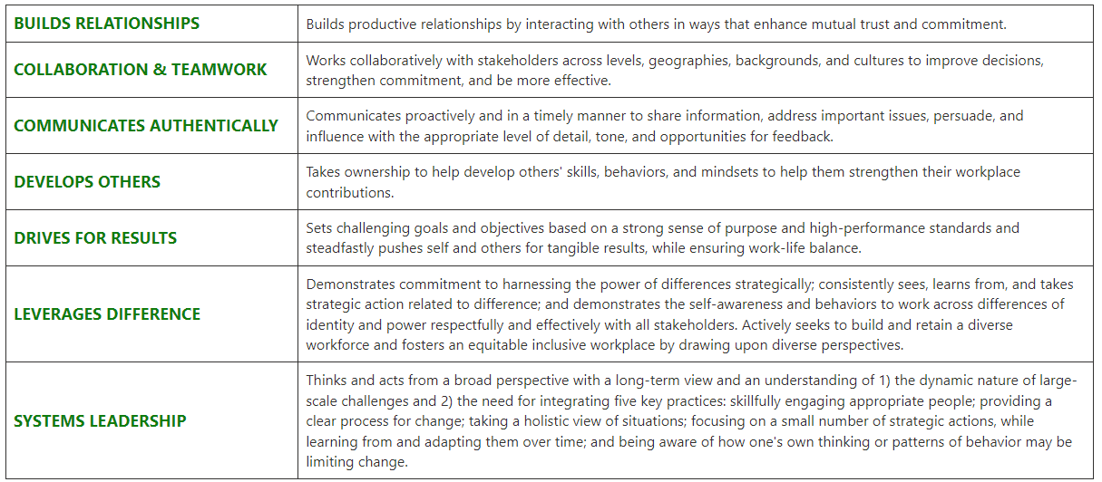
The Nature Conservancy is an Equal Opportunity Employer. Our commitment to diversity includes the recognition that our conservation mission is best advanced by the leadership and contributions of people of diverse backgrounds, beliefs, and cultures. Recruiting and mentoring staff to create an inclusive organization that reflects our global character is a priority and we encourage applicants from all cultures, races, colors, religions, sexes, national or regional origins, ages, disability status, sexual orientations, gender identities, military, protected veteran status or other status protected by law.
TNC is committed to offering accommodations for qualified individuals with disabilities and disabled veterans in our job application process. If you need assistance or an accommodation due to a disability, please send a note to applyhelp@tnc.org with Request for Accommodation in the subject line.

