Outreach Notice
GS-0401/1701-11 Natural Resource Education Specialist
Permanent Full Time
Monongahela National Forest
Elkins or Seneca Rocks, West Virginia

Notice valid from April 11, 2022, to May 16, 2022.

The Monongahela National Forest will be advertising to fill one permanent, full time Natural Resource Education Specialist (GS-0401/1701-11) position with a duty location of Elkins or Seneca Rocks, West Virginia. The purpose of the outreach is to inform the vacancy announcement process and provide a point of contact for interested individuals to obtain additional information about the job opportunity and the community.

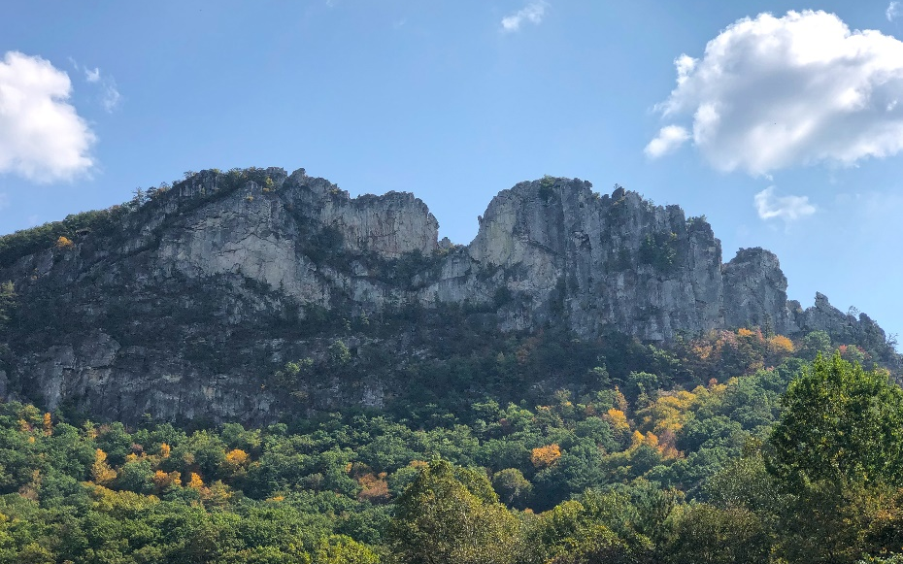
Primary Contact
Kelly Bridges
Public Affairs Officer
kelly.bridges@usda.gov

About the Position
The position is located in a Forest Supervisor’s Office where the incumbent is responsible for planning, developing, coordinating, evaluating, and managing delivery of the Forest’s Conservation Education program, including building partnerships and writing grants that support the program.

Duties include:
Education Outreach Program Planning, Development, Coordination, and Administration
- Provides professional natural resource and education guidance and expertise for the planning, development, implementation, and evaluation of the Forest’s conservation education strategies and programs.
- Ensures natural resource conservation education programs and projects include, describe, and explain the Forest Service mission, history, and current management within the context of the best scientific information. Ensures programs and projects meet accepted standards. Recognizes problems that may develop in the program and recommends preventative or mitigating actions. Coordinates natural resources conservation education activities with Forest leadership and resource areas to ensure effective explanation of agency science, management activities, and recreation opportunities. Develops conservation education strategies designed to attract target audiences. Responsible for the administration, direction, management, and control of the education outreach programs for visitors.
- Assists in development of and oversees the implementation of education outreach programs provided to visitors and special groups, such as schools and professional groups, by employees, seasonal employees, interns, volunteers, and staff. Occasionally provides off-site programs to colleges, schools, and civic groups.
- Responsible for budget estimates for all education outreach activities. Inspects physical education facilities such as nature trails, wayside exhibits, signs, interpretive, information, and audiovisual installations. Coordinates with others in the preparation of articles for publication in newspapers and magazines outlining the various programs that are available.
- Serves as the Forest’s Education Outreach Coordinator. Coordinates with senior staff and oversees Forest participation in education activities such as local shows and fairs and assists with special events at field office locations. Responsible for coordination and execution of major outreach events within the Forest.

Natural Resource Education Materials Development, Studies, and Evaluations
- The incumbent develops and implements criteria and tools to evaluate program/project effectiveness in meeting state and national educational standards and collaborates with partners to evaluate the Forest’s conservation education materials. Develops conservation education materials and programs that meet educational standards. Investigates potential program improvement projects and conducts special studies.

Natural Resources Conservation Education Coordination, Partnerships, and Contract Work
- Serves as Conservation Education partnership coordinator. Develops guidelines, translates regulations to the field level, administers agreements, ensures procedures are followed, provides technical expertise, and ensures records are maintained.
- Responsible for seeking natural resource conservation education outreach-related grants, and for coordinating and screening forest grant applications.

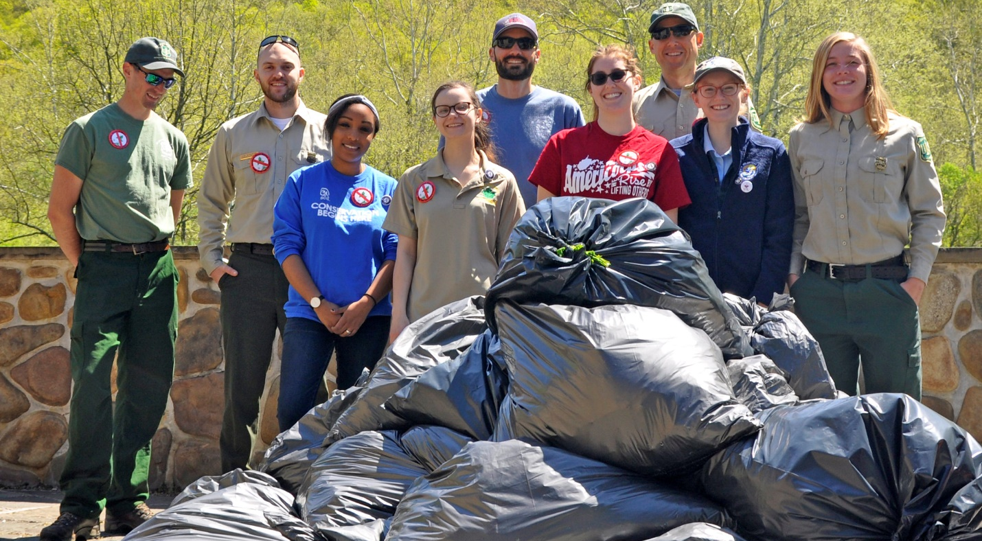
About the Forest
Monongahela National Forest includes more than 919,000 acres in 10 counties in the highlands of the West Virginia. Located within a day's drive of about half of the nation's population, the Forest is both popular and accessible; yet feels remote and wild.

The Monongahela is one of the most biologically diverse national forests and is considered by The Nature Conservancy to be in an area of global ecological importance. Much of this diversity can be attributed to the wide variations in elevation and the resulting patterns of precipitation. The lowest part of the Forest is on the eastern side at about 1,000 feet above sea level, while the central portion of the Forest contains the state's highest point, Spruce Knob, at an elevation of 4,863 feet above sea level. The western side of the Forest receives about 60 inches of precipitation per year while the "rain shadow" side to the east receives half of that.

The mountains lie in a northeast to southwest pattern, with valleys between for most of the Forest. Rivers and streams are abundant, and act as a travel corridor for both plants and animals, which further increases the biological complexity. At least 75 tree species are found in the Forest, more than 225 species of birds, eight federally listed threatened or endangered species of birds, bats, salamanders, and plants, 60 species of nongame/forage fish, 12 species of game fish.

Snow is common in winter, while spring brings moderate temperatures perfect for trout fishing. Spring wildflowers are abundant. Summers are typically moderate, with pleasantly sunny days perfect for camping and hiking. The forest is a favorite destination in the fall, when the days turn cooler, and the trees feature a beautiful palate of reds, oranges, and yellows. For more about Monongahela National Forest, visit https://www.fs.usda.gov/mnf.

How to Apply
If you are interested in this position or would like additional information, please respond to this notice on the outreach database, fill out the voluntary outreach response form, and return it along with your resume to Kelly Bridges at kelly.bridges@usda.gov.

The U.S. Department of Agriculture (USDA) prohibits discrimination in all its programs and activities on the basis of race, color, national origin, age, disability, and where applicable, sex, marital status, familial status, parental status, religion, sexual orientation, genetic information, political beliefs, reprisal, or because all or part of an individual’s income is derived from any public assistance program. (Not all prohibited bases apply to all programs.) Persons with disabilities who require alternative means for communication of program information (Braille, large print, audiotape, etc.) should contact USDA’s TARGET Center at (202)720-2600 (voice and TDD). To file a complaint of discrimination, write to USDA, Director, Office of Civil Rights, 1400 Independence Avenue, S.W., Washington, DC 20250-9410, or call (800) 795-3272 (voice) or (202) 720-6382 (TDD). USDA is an equal opportunity provider and employer.
MONONGAHELA NATIONAL FOREST
OUTREACH NOTICE FORM
POSITION TITLE: Natural Resource Education Specialist (GS-0401/1701-11)
UNIT: Monongahela National Forest, Elkins or Seneca Rocks, West Virginia
PERSONAL INFORMATION
NAME:
E-MAIL ADDRESS:
MAILING ADDRESS:
CITY, STATE, ZIP CODE:
TELEPHONE:

CURRENT EMPLOYMENT STATUS
AGENCY:
LOCATION:
POSITION TITLE/SERIES/GRADE:
TYPE OF APPOINTMENT:

If you are not currently a permanent (career or career conditional) employee, are you eligible to be hired under any of the following special authorities?
Person with Disabilities
Veteran’s Readjustment Authority
Disabled Veterans with 30% Compensable Disability
Veteran’s Employment Opportunities Act of 1998
Former Peace Corps Volunteer
Other (Please Identify):
Please respond to this notice on the outreach database, fill out the voluntary outreach response form and return it along with your resume to Kelly Bridges at kelly.bridges@usda.gov before the expiration of this outreach. Thank you for your interest!

