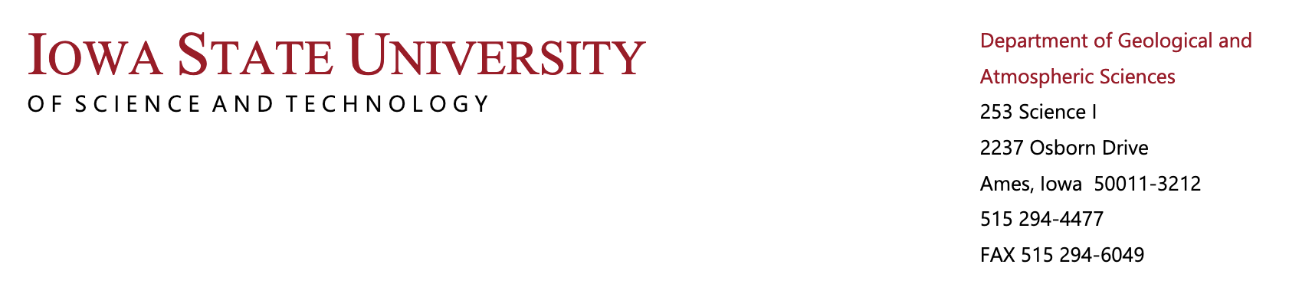

The Department of Geological and Atmospheric Sciences offers graduate programs in Geology, Meteorology, and Earth Science. More information about the application process is available on the departmental website (https://ge-at.iastate.edu/). Faculty within the department are currently recruiting graduate students for the following positions to start in Fall 2022.

Biogeochemistry
Dr. Betsy Swanner (eswanner@iastate.edu) is recruiting a PhD student funded by RA/TA to start Fall 2022 to study biogeochemical processes carried out by cyanobacteria and bacteria in stratified lakes.
https://geobiochem.ge-at.iastate.edu/

Climate Modeling
Dr. Bill Gutowski (gutowski@iastate.edu) is not recruiting at this time.

Convection and boundary layer processes
Dr. Ian Williams (inw@iastate.edu) is recruiting one or two MS or PhD students for funded research assistantships in the area of modeling and remote sensing of convective clouds/storms and their interactions with Earth's surface and boundary layer, on weather and climate timescales. Depending on student interests, training will be provided in the use of remote sensing observations, numerical weather prediction models, land surface models, or global climate models.
https://faculty.sites.iastate.edu/inw/

Dynamic Meteorology
Dr. Alex Gonzalez (agon@iastate.edu) is not recruiting at this time.
https://tad.ge-at.iastate.edu/

Earth History and Earth System Evolution
Ben Johnson (bwj@iastate.edu) is recruiting an MS and/or PhD student to work in the broad field of Earth System Evolution and Astrobiology. Specific projects include investigating the evolution of land plants on N, C, and S cycling; deep time atmospheric composition; and oxygen isotope paleoaltimetry.
https://www.benwjohnson.com

Economic Geology
Dr. Paul Spry is not recruiting at this time.

Extreme Weather and Climate Variability/Change
Prof. Christina Patricola (cmp28@iastate.edu) is seeking MS and/or PhD students to investigate the large-scale drivers, local-scale processes, and coupled feedbacks that determine variability and change in extreme weather events (such as tropical cyclones) using global and/or regional climate models and observations. The position will be funded by a research assistantship. https://faculty.sites.iastate.edu/cmp28/

Geophysics and Seismology
Dr. Igor Beresnev (beresnev@iastate.edu) is recruiting a MS or PhD student to investigate earthquake-source properties using strong-motion data and numerically simulate earthquake radiation for seismic-hazard assessment. This position is funded by a teaching assistantship.
https://faculty.sites.iastate.edu/beresnev/

Glaciology
Dr. Neal Iverson (niverson@iastate.edu) is recruiting a MS or PhD student for laboratory, modeling, or field studies of glacier sliding or ice permeability. This position is funded by research and teaching assistantships. https://geat.iastate.edu/directory/neal-iverson/

Global Urbanization and Implications in Building Energy Use
Dr. Yuyu Zhou (yuyuzhou@iastate.edu) is recruiting one PhD student to focus on research in the topic listed above. This student will be supported through a combination of research and teaching assistantships. https://ge-at.iastate.edu/directory/yuyu-zhou/

Paleoclimatology
Dr. Al Wanamaker (adw@iastate.edu) is not recruiting at this time.
https://siperg.las.iastate.edu/

Structural Geology
Dr. Jacqueline Reber (jreber@iastate.edu) is not currently recruiting for Fall 2022. Please see her website for general information.
https://structure.ge-at.iastate.edu/

Surface Water Hydrology
Dr. Kristie Franz (kfranz@iastate.edu) is not recruiting at this time.
https://faculty.sites.iastate.edu/kfranz/projects

Synoptic and Mesoscale Meteorology
Dr. Bill Gallus (wgallus@iastate.edu) is not recruiting at this time.
https://faculty.sites.iastate.edu/wgallus/project/improved-understanding-nocturnal-mesoscale-convective-system-evolution

