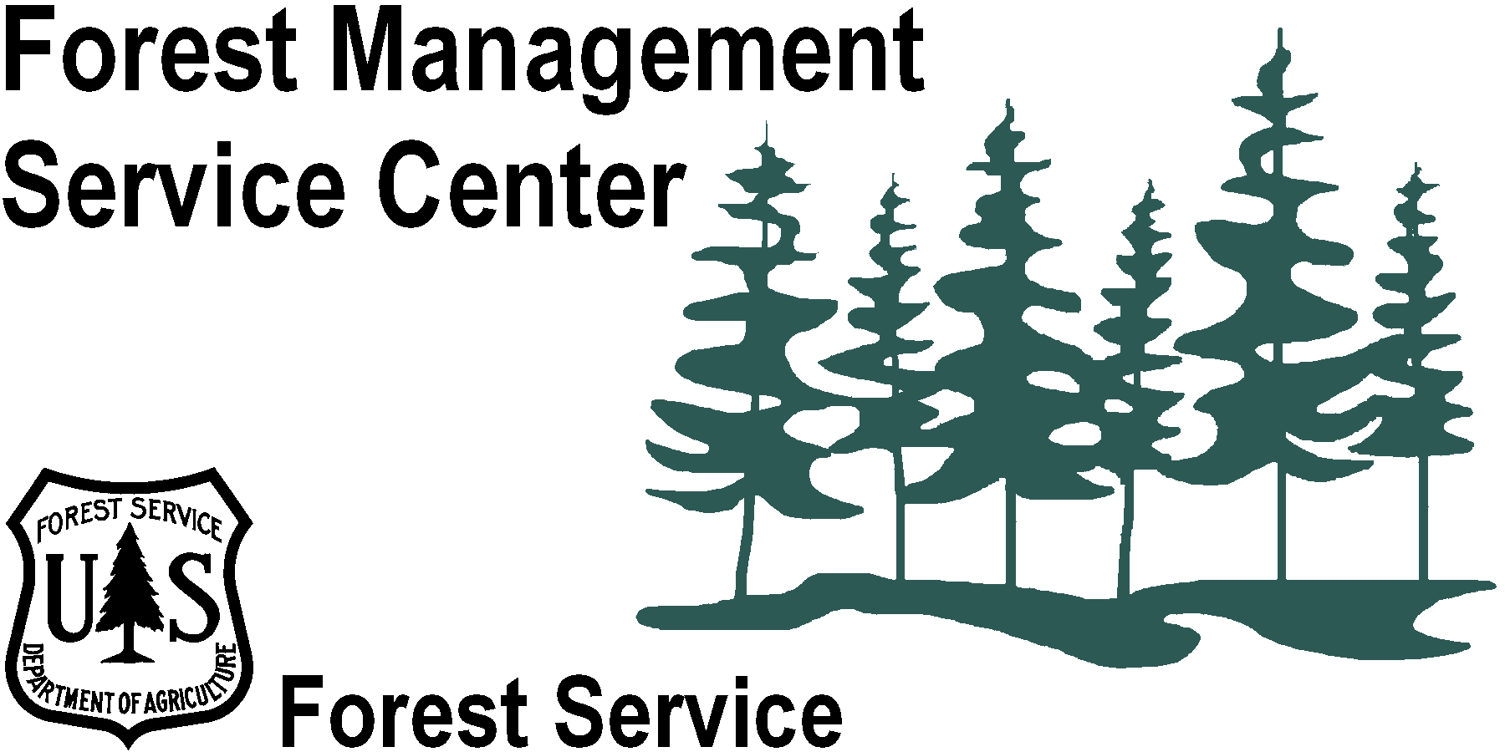

OUTREACH NOTICE – POSITION TO BE ADVERTISED
Forester/Mathematical Statistician
GS-0460/1529-11/12
USDA Forest Service
Washington Office Detached
Forest Management Service Center
Fort Collins, Colorado

July 9, 2020

OUTREACH RESPONSE
Interested applicants, or those desiring further information, may contact Mike Van Dyck, Forest Vegetation Simulation Group Leader, by email (mvandyck@fs.fed.us).

THE POSITION TO BE ADVERTISED
This position is a permanent, full time GS-0460/1529-11/12 Forester/Mathematical Statistician with a duty station of Ft. Collins, CO. it is a part of the Forest Vegetation Simulator (FVS) Staff in the Forest Management Service Center (FMSC). This notification is being circulated to inform prospective applicants of the upcoming opportunity and to determine interest in the position.
As part of the Forest Management Service Center, the position supports the Center’s biometric and computer software support activities. Duties include developing, validating, and reviewing mathematical models for incorporation into FVS and assisting users of the models. The Center is looking for someone with strong mathematical skills and a background in forest biometrics. Knowledge of forest growth and yield modeling is desired.
The Forest Vegetation Simulator Software
The Forest Vegetation Simulator (FVS) is a model used for predicting forest stand dynamics over time. This type of model is commonly referred to as a forest growth and yield model. FVS is the most widely used model of this type in the world, and is the standard model used by various US government agencies including the USDA Forest Service, USDI Bureau of Land Management, and USDI Bureau of Indian Affairs. It is also used by state agencies, educational institutions, industry, and private landowners.
FVS is used extensively to summarize current stand conditions and predict future stand conditions under various management and disturbance alternatives. Output from the model is used for forest planning, wildlife habitat suitability, insect hazard, predicted wildfire losses, carbon accounting, and many other types of analysis. In addition, FVS has been linked to other Forest Service corporate software.
Further information regarding the FVS software can be found at https://www.fs.fed.us/fvs
The Forest Vegetation Simulator Staff
The FVS staff is made up of a combination of foresters, statisticians, and a computer programmer. All are well educated, highly motivated, and productive. When fully staffed there are six staff members, and the duties are quite varied, so each member is involved in a variety of different tasks. Duties include model development and testing, software development and maintenance, documentation, user support, training, and more. The FVS staff collaborates with and provides support for the Forest Service and many people outside of the agency.
The Forest Management Service Center
The Forest Management Service Center (FMSC) located in Fort Collins, Colorado and is a detached unit of the Forest and Rangeland Management and Vegetation Ecology (FRMVE) staff of the Washington Office. The FMSC houses the Forest Vegetation Simulator staff and the Forest Products Measurements staff and provides products and technical support for growth and yield software and timber cruising, scaling, surveying. Users represent nearly every discipline related to forested lands. The Center is co-located with other Forest Service units, and there is frequent integration with these other staffs.

MAJOR DUTIES
Designs, develops, adapts, documents, and tests analytical techniques and computer models, primarily in the area of forest vegetation modeling. This includes using a variety of programming techniques, statistical concepts, and computer software packages.
Works closely with research scientists from Government Agencies, Universities, and Private Industry to develop, validate, and review mathematical models. Analyzes and provides solutions for forest management problems and issues related to forest measurements and forest growth and yield. Incorporates solutions into field-oriented software systems.
Evaluates and maintains forest vegetation modeling software for use in production applications at all levels of the Forest Service, as well as outside the agency. This involves the use of databases and various computer programming languages and operating systems.
Provides expert assistance to software users through training, documentation, hotline support, meetings, and symposia. Assists other Service Center staff in debugging, verifying, and assuring correct results from Service Center software.

LOCATION DESCRIPTION
Fort Collins is an ideal mix of beautiful climate, friendly people, great recreational opportunities and culture. It is located in Larimer County where over 50 percent of the county is publicly owned. It has numerous parks just a walk away from any neighborhood, and miles of trails and bike lanes allow you to navigate the city by bicycle. It is consistently ranked as one of the best cities in the country in which to live.
Fort Collins is situated at the eastern base of the Front Range of the Rocky Mountains alongside the Cache la Poudre River. It is approximately 65 miles north of Denver and 45 miles south of Cheyenne, Wyoming on Interstate 25. The elevation of Fort Collins is approximately 5,000 feet above sea level.
Fort Collins enjoys a moderate, four-season climate. Because of its location along the foothills of the Rocky Mountains, Fort Collins is buffered from extremes of both summer and winter weather. Warm, dry days and mild nights are common in Fort Collins. It averages 296 days of sunshine and 14.5 inches of precipitation each year. The average temperature in July is 71 degrees; 22 degrees in January.
Fort Collins is home to Colorado State University. Elementary and secondary schools rank among the States best. There are also private and Church-affiliated schools and day care facilities. Fort Collins has a large and excellent medical community with a wide variety of specialists, several clinics, and one hospital. Cultural opportunities abound. The median sales price of homes in Fort Collins in April 2020 was $423,000. More Information about Fort Collins, Colorado can be found at http://www.city-data.com/city/Fort-Collins-Colorado.htm

