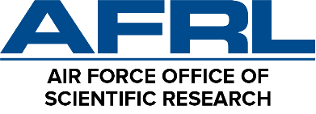
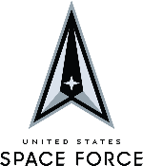
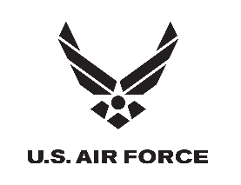

AFRL/AFOSR Basic Research National Science Portals Pilot (NSPP)
Funding Opportunity Announcement (FOA) Informational Webinar

AGENDA
Monday, 10 April 2023
1300-1435 ET
Zoom Webinar (General Attendees):
https://www.zoomgov.com/webinar/register/WN_fBjW8DuxQU-fR0WVExBVsg
Webinar ID: 160 143 7580 • Passcode: 62517744

*Webinar will open to general attendees at 1255
Start | End | Duration | Description / Topic | Speaker
1300 | 1315 | 15 min | Opening Remarks and Overview of AFRL Basic Research National Science Portals Program | Dr. Irina Pala  AFRL/AFOSR Deputy Division Chief, Science & Engineering Division
1315 | 1325 | 10 min | Acquisitions Overview for Funding Opportunity Announcement | Mr. Calvin Scott  AFRL/AFOSR Senior Procurement Analyst, Contracting Division
1325 | 1340 | 15 min | Technical Topic: Directed Energy | Dr. John Luginsland  AFRL/AFOSR Program Officer,  Science & Engineering Division
1340 | 1350 | 10 min | Break
1350 | 1405 | 15 min | Technical Topic: Fluid Surface Material Interaction | Dr. Gregg Abate  AFRL/AFOSR Program Officer,  Science & Engineering Division
1405 | 1425 | 20 min | Technical Topic: Data Models: Machine Learning for Scientific Discovery | Dr. Fariba Fahroo and Dr. Ali Sayir  AFRL/AFOSR Program Officer,  Science & Engineering Division
1425 | 1435 | 10 min | Final Remarks from Science & Engineering Division | Dr. Irina Pala  AFRL/AFOSR Deputy Division Chief, Science & Engineering Division
1435 |  |  | Adjourn

