Creation of an Integrated Science Program at NCAR
January 12, 2008

Almost every major research institution recognizes the importance of addressing major environmental issues, and in turn, they recognize that this requires collaboration and cooperation across many disciplines and investment in non-traditional areas of science. Although a large number of centers and institutes have been created with this objective in mind, these same institutions have consistently struggled to put into place successful mechanisms to promote scientific frontiers that are dependent on both new directions and integrated approaches. The most notable successes and failures all revolve around five questions:
- Does the management structure promote a sense of shared responsibility and commitment or competition with established units?
- Is the extra institutional burden borne by management “behind the scenes” or is it borne by scientists themselves?
- Do the scientists sense a commitment from the institution and, critically, their peers which translates into job security, successful promotion, and access to collaborative opportunity and reward?
- Does the structure promote the natural tendencies of scientists to work together on interesting problems or does it result in a sense of isolation or top-down directed collaboration?
- Do the resources match the vision or problem?

Clearly, mission-oriented institutions have additional challenges if part of the full breadth of disciplines is outside their purview.
The NCAR Institutes were established October 1, 2004 with different scientific foci but with the identical, overarching objectives of creating new venues for University-NCAR interactions and cooperation, promoting new and innovative research directions, and promoting research that would cross traditional boundaries within NCAR.

A review of the NCAR Institutes was undertaken in 2008 to evaluate Institute success in achieving these objectives and to discuss options for improvement. The review included a survey of participants, including NCAR managers, and an Executive Committee retreat. Overwhelmingly, participants valued the Institute function of promoting integrated activities and frontiers. Reviewers consistently highlighted activities such as the Theme of the Year workshops and specific projects (e.g. BEACHON) as highly valued. IMAGe received a strong endorsement for its activities. The reviews indicated the importance of a continuing effort at NCAR to support the objectives proposed for the NCAR Institutes. While there have been notable successes associated with these new institutes, much can be improved.

The review indicates that NCAR can do a much better job of addressing the five issues that contribute to the success of frontier interdisciplinary endeavors as described above, particularly for ISSE and TIIMES. More directly, the survey of participants and NCAR managers challenged NCAR to:

- Seek opportunities to increase our investment in integrated scientific objectives
- Ensure a more coherent advocacy for the integrated scientific objectives by mitigating cumbersome or confusing management components and identifying a leader at a high level in the organization
- Ensure that frontier enterprises are embedded into the institution, in order to take full advantage of the potential for collaboration within NCAR
- Provide more direct access to NCAR leadership by the Institute scientists and thereby reduce any perception of uncertain commitment or interest in integrated scientific objectives
- Reduce the burden on scientists involved in integrated scientific activities currently associated with increased bureaucratic responsibilities (meetings, reports, etc) and overly complex supervisory roles
- Promote more cohesive and collaborative interactions between Institute and Lab/Division management in budgeting, planning, and implementation
- Ensure that the scope of the integrated scientific enterprise matches the available resources

The atmospheric, oceanic, and related Earth sciences are central to tackling the most compelling environmental issues of this century and, consequently, the potential for NCAR to contribute is enormous. However, to achieve this potential, NCAR must be responsive to the challenges articulated by Institute participants and NCAR managers. The NCAR Executive Committee proposes to create a single pan-NCAR Integrated Science Program (ISP). ISP will initially focus on the current scientific objectives of TIIMES and ISSE, and will be a partner to the Advanced Study Program (ASP). ASP works across NCAR to promote human capacity in the atmospheric and related sciences by encouraging the development of early career scientists, faculty fellowships, and continuing education. ASP is recognized as a true partner by NCAR units and by the atmospheric sciences community. ISP will have a role that is similar to the ASP, but focused on integrated, interdisciplinary research. ISP will work across NCAR to facilitate projects and activities, and promote new science directions, through close partnership with NCAR’s Laboratories and the community.
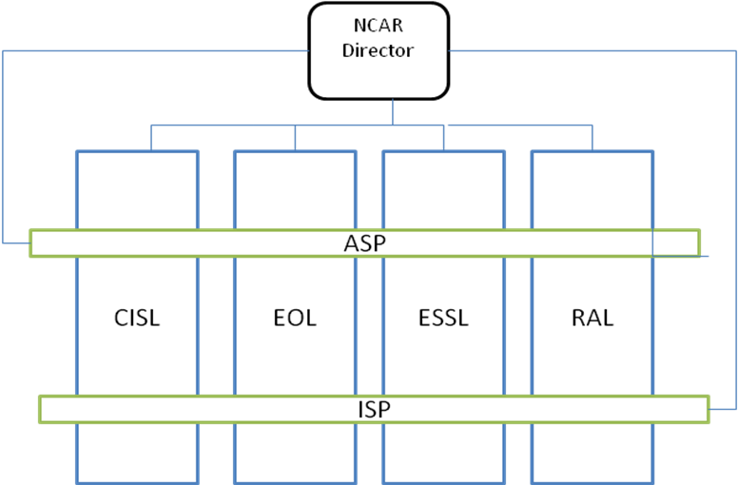
The ISP Mission:
The Integrated Science Program will promote scientific frontiers that are dependent on an integrated approach, across NCAR laboratories and across disciplines. ISP will focus on thematic areas where the mission and expertise at NCAR, and in the university atmospheric and related sciences community, can be advanced by contributions from the social and environmental sciences beyond those that typically occur within single programs or departments. These areas include, but are not limited to, Earth system-society interactions, building societal resilience to weather and climate hazards, hydrologic sciences, and biogeochemistry.

The characteristics of the ISP are:
- The Director of the ISP will report to the Director of NCAR and will be a member of the NCAR Executive Committee. This action provides direct access to NCAR leadership, promotes joint decision-making with Lab directors, and elevates the commitment within NCAR to innovative directions and to activities that cross Laboratory and disciplinary boundaries. The Director will lead efforts to promote innovative research that crosses traditional boundaries and to define thematic areas for investment. The Director will play an active role in developing, promoting and evaluating the success of sponsored projects and in developing a sense of community in thematic areas that cross the Labs. The ISP Director should be much like the ASP Director – someone who has active and cross-cutting research interests but who is keenly interested in acting as a leader, broker, facilitator and coordinator (addresses concerns 2, 3 and 4) that will promote the success of NCAR as a whole. As with ASP, the Director of ISP will be a rotating position, proposed with a five year term that is renewable for one five-year term.
- The ISP will include ISSE and TIIMES, and therefore will initially adopt the strategic planning priorities of ISSE and TIIMES to ensure continuity of the projects and personnel within the Institutes.
- The ISP will have an active internal advisory structure with Lab representation that assists with ISP planning, helps ISP establish themes and priorities, and reviews and advises on project proposals and personnel decisions and ensures that decisions are collaborative and cohesive. (addresses concerns 4 5and 6). As with other units, the ISP will also seek separate advice from external constituents through the NCAR advisory committee structure.
- The ISP will have resources to (addresses concerns 4 and 5)
  - Promote vibrant visitor programs and organize workshops
  - Invite and fund proposals in theme areas (established by ISP and NCAR strategic planning and agreed upon with ISP advisory committee) in two categories:
    - Short-term investment in new areas: Fixed-term project support proposals from Laboratories (originating from their units, scientists and engineers and endorsed by laboratory and division directors). A partnership between ISP and a Lab(s) is a requirement for all funded proposals (see example 1 below for more detail).
    - Long-term investment in personnel: New ladder hires who will reside in the Laboratories (see example 2 below for more detail).
- The ISP will serve as a facilitator and an investor in integrated research directions, rather than as an entity that sees itself as a sole owner of a portion of the research landscape or individuals working on thematic areas. (addresses concerns 1 and 5)
  - In the case of the short-term projects, successful proposals for ISP funds will be managed by the PI. They will have defined end dates and a scope that will ensure appropriate budget and planning and, once the end date is reached, the resources will be available to allow the ISP to invest in new projects. In this mode, ISP acts as an incubator, which may promote supporting external proposals or an opportunity to explore new strategic areas.
  - In the case of long-term investments in new personnel, the dollars for these new individuals will be transferred to the unit(s) that proposed the position once the individual is hired. This is a long-term commitment to the individual and to the proposing unit(s). The proposing unit(s) will manage annual reviews and promotion, while incorporating the views of the ISP Director. The dollars are returned to ISP to promote new hires should an ISP-funded individual leave NCAR or significantly change the scope of their research. Any significant change in scope would be assessed through a formal review process.
  - ISP will have an obligation to facilitate the interaction of individuals across NCAR who are identified with themes and to promote these themes at the Executive Committee. in strategic planning, and to help ensure visibility within and outside of NCAR.
- All scientists and engineers who currently derive their salary from ISSE and TIIMES will have permanent homes in Laboratories (these individuals will be assigned to labs and divisions through mutual agreement of ISP, the relevant lab/division and the affected individual). Should any of these individuals leave, their salary is returned to ISP so that ISP can promote new hires in thematic directions. (addresses concern 5)
- The reduction in the number of managers will create additional resources that can be utilized to support the mission of ISP. This consolidation represents an opportunity for the strategic priorities of current NCAR Institutes to be funded without the requirement for incremental dollars. The end dates of the current Strategic Initiative funds may also provide an opportunity for ISP funding (partially addresses concern 7)

ISSE and TIIMES will be maintained under the ISP banner for the time necessary to ensure continuity and to ensure uninterrupted visibility of these activities within NCAR, but without their separate managerial functions. ISP will seek to increasingly highlight “named” programs that become flagship enterprises in NCAR’s contributions to social and environmental sciences through integrated research efforts.

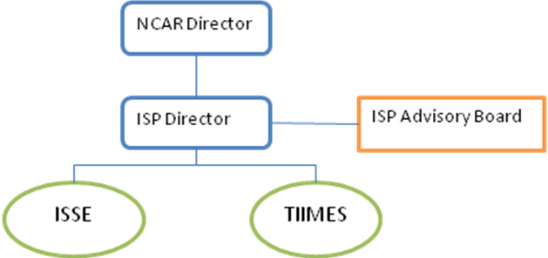

The role of ISP is intended to mirror that of ASP in terms of its collaboration with NCAR units, but ISP will focus on facilitating and investing in integrated research while ASP focuses on human capacity building. ISP is designed to be a true partner with the Labs and their units rather than as sole owner of part of the research domain. A few examples may provide a clearer picture of its operation:

Example 1. New Funded Projects
ISP, based on its strategic plan, will work with its internal advisory committee to define a new call for proposals. This new call will be based on a particular theme or themes (an example might be water resources). The call will be for a defined range of budgets and for a finite time span (5 year projects, with a 2.5 year review to determine whether the project will ramp down or continue to the end date; no extensions beyond 5 years will occur; new proposals will be required to compete with other ideas). Groups of individuals are invited to write proposals for salary support, travel, project support etc. to address a research objective. Only proposals that have the concurrence of the Lab(s), which explicitly describe the willingness of the Lab(s) to commit their staff (and at what level) and accept the time scale of support, are accepted for review. The ISP Director, in consultation with the ISP Advisory Board, decides on the most worthy projects for support. Advice from the external advisory committee may also be sought. The selected project(s) will then be managed by the PI(s), within a lead Laboratory (ies). ISP takes credit by announcing that it is supporting a project in one or more NCAR Lab. At the end of the project life span, the dollars will be available to ISP for an additional call for proposals. Projects cannot be renewed, and instead, a new proposal would be required and would become a part of the competition for these resources. Highly successful projects are likely to garner external funding, which would allow support to continue without ISP project resources.

Example 2. A New Hire
ISP, based on its strategic plan and budget, will work with its internal advisory committee to define thematic areas for new ladder scientist hires (for instance, two new Scientist I positions within thematic areas such as Integrated Assessment Modeling, Weather-Society Interactions, Urban Environments, etc.). Concurrence between a Lab(s) and the ISP Director (either in response to a call for proposals or overlap between strategic plans of ISP and the Lab) would result in an advertised position. The Lab(s) will then run the searches, and offer positions to two candidates with the ISP Director’s concurrence. The dollars for the support of these individuals will then be transferred to the Lab(s) and they will take responsibility for annual reviews and for promotion. The ISP Director will be consulted in each case. Should either of these individuals leave, or significantly change research direction, the dollars will be returned to ISP to promote additional hires or may be transferred by agreement between ISP and the Lab(s) to a new individual working on ISP themes. In this manner, ISP promotes a long-term commitment to a new research direction and a thematic area, but in full partnership with a Lab(s). ISP has an obligation to help promote a sense of community among individuals with interest in any theme, including those who work at NCAR, or in the university community.

Example 3. Staff currently affiliated with ISSE
All individuals currently supported by ISSE will be asked to identify a home Lab/Division, with Lab concurrence. It is expected that their choices are likely to result in a limited number of clusters, which could become sections and ensure a visible representation of ISSE programs. Visibility of the ISSE research agenda is of key importance and the ISP Director has an obligation to ensure that the external community and NCAR recognize the breadth and depth of NCAR efforts. These sections would embody current projects within ISSE and may allow us to develop unit names that demonstrate our commitment to ISSE-type activities. The appropriate personnel budget will be transferred to the identified Lab(s), which will assume responsibility for annual reviews and for promotion. The ISP Director will be consulted in each case. Should this individual leave, or significantly change research direction, the dollars will be returned to ISP to promote additional hires or can be transferred by agreement between ISP and the Lab(s) to a new individual working on ISP themes. ISP has an obligation to help promote a sense of community among individuals with interest in any theme who work at NCAR and in the university community.

Example 4. Staff currently affiliated with TIIMES
Individuals funded by TIIMES already have homes within Labs, but these tend to be partially funded. ISP will continue to provide this support to avoid negative budget impacts on the NCAR Labs. The NCAR Director, ISP Director, and Lab Director will identify a subset of the resources that can be tagged as ISP “positions” so that they can follow the rules described above for all other positions (i.e. the Lab takes responsibility for annual reviews and for promotion). The ISP Director is consulted in each case. Should this individual leave, or significantly change research direction, the dollars are returned to ISP to promote additional hires or can be transferred by agreement between ISP and the Lab to a new individual working on ISP themes). Again, ISP has an obligation to promote a sense of community among individuals interested in any theme.

Example 5. Existing Programs supported by TIIMES and ISSE
ISSE and TIIMES both support large cross-cutting programs that fund individuals or portions of individuals in multiple NCAR laboratories and Divisions to work on agreed projects and activities.
These projects are in two forms, defined-term projects and coherent groups representing long-term enterprises. Defined-term projects will be managed in a PI(s) mode within a lead Laboratory(ies), giving the PI budget authority in consultation with the Division/Lab and ISP Director and the opportunity to contribute to the annual review of project participants. At the end of the project life span, the dollars will be available to ISP for an additional call for proposals. For long-term enterprises, ISP will distribute the funding for these activities to divisions and laboratories under terms agreed to by ISP and the management of the relevant organizational unit. Funding for individuals working on projects will be transferred by ISP to the relevant lab as described in example 3 and 4 above. ISP will negotiate with labs and divisions to identify and agree on individuals who will reside in labs and divisions and continue to lead these activities. Non-labor funding to support programs will be transferred to the unit that agrees to host the program manager. ISP will facilitate collaborative decision-making about priorities and direction within these programs and work with labs and divisions to track progress. If Labs or Divisions decide that they no longer wish to participate in and support such programs, or individuals depart, then the funding for the effort will revert to ISP.

