News in This Quarter

WindSat Winds Operational at Fleet Numerical Meteorology and Oceanography Center
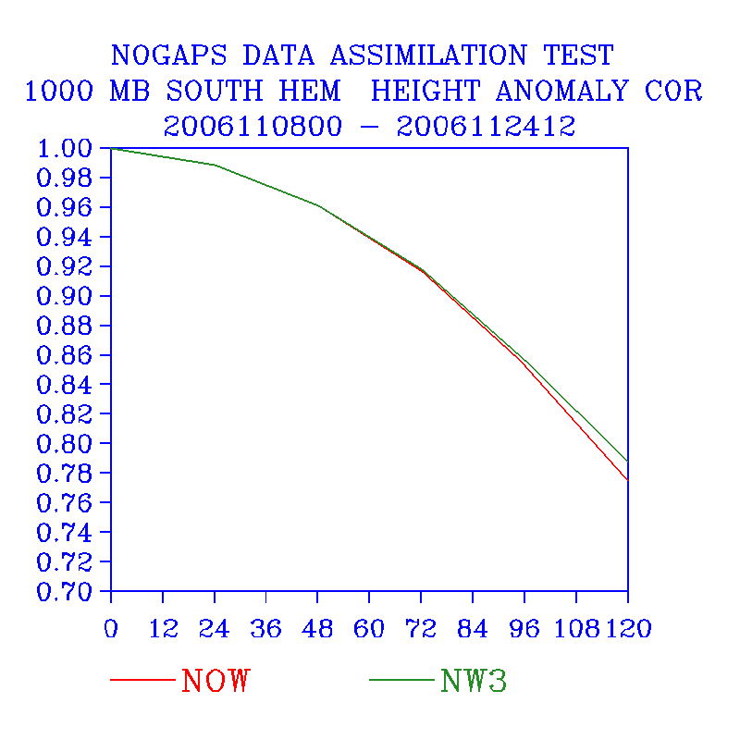
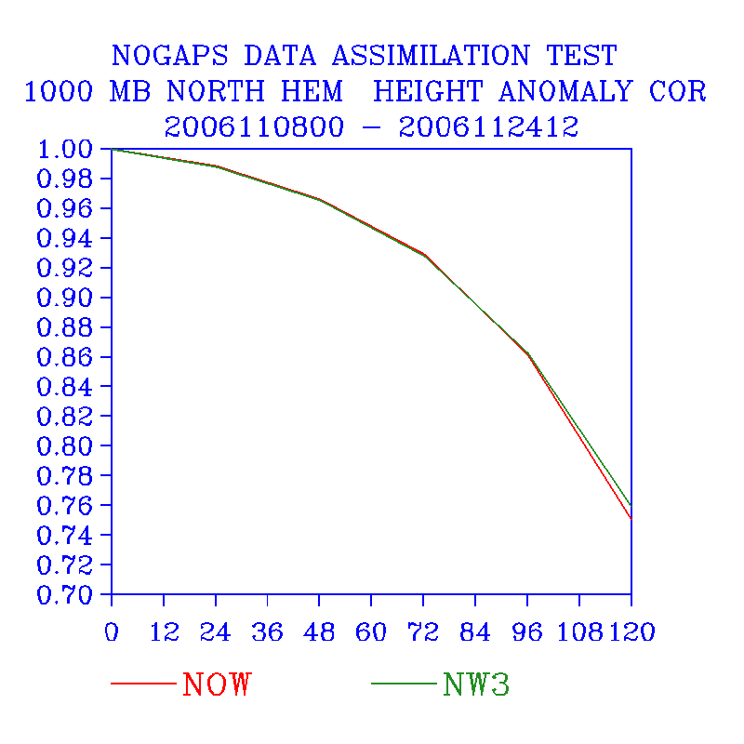
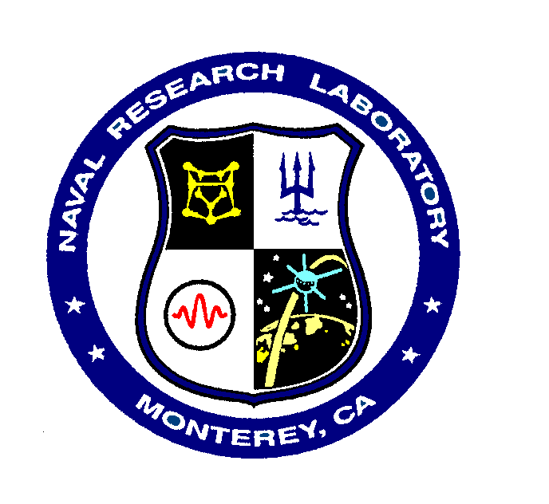
WindSat Impact
1000 mb Height Anomaly Correlation
Northern Hemisphere
Southern Hemisphere
No WindSat
WindSat
November 8 - 24, 2006

1000 mb height anomaly correlations as a function of forecast range for the Northern Hemisphere (left) and the Southern Hemisphere (right) for experiments with (green) and without (red) WindSat oceanic surface winds

WindSat oceanic surface vector winds went into operational use at Fleet Numerical Meteorology and Oceanography Center (FNMOC) in the U.S. Navy’s global data assimilation and modeling systems on 20 December 2006, after testing by the Naval Research Laboratory-Monterey (NRL) and beta-testing by FNMOC showed small but positive impacts. The WindSat instrument is a multi-frequency polarimetric microwave radiometer developed by the Naval Research Laboratory in Washington, DC. It is the first passive instrument (as opposed to active instruments such as scatterometers) designed to provide information on ocean surface wind speed and direction. The software to derive the ocean surface wind vectors was developed at NRL-DC principally by Mike Bettenhausen, Peter Gaiser and Bill Johnston. The performance of the WindSat winds in the NRL Atmospheric Variational Data Assimilation System (NAVDAS) is similar to that for scatterometer surface winds from QuikSCAT and ERS2, which are also used operationally.

A pre-operational test was performed for the period 8-24 November 2006. The figure shows a comparison of the 1000 mb height anomaly correlation with and without WindSat winds. The addition of WindSat led to an improvement in performance at longer time ranges, especially in the Southern Hemisphere. The 500 mb height anomaly correlations (not shown) also had a slight improvement associated with using the WindSat data. This contrasts with earlier testing using a dataset from August-September 2004, in which no significant improvement or degradation was found, suggesting that the recent update to the WindSat processing software was beneficial.

(Patricia M. Pauley, James S. Goerss, NRL, and Randal L. Pauley, FNMOC)



International Items: Data Assimilation at the Australian Bureau of Meteorology

The current operational data assimilation system for NWP at the Australian Bureau of Meteorology is an observation-space assimilation methodology, GenSI (Steinle, 2005), which was designed to provide a 3D variational assimilation system that can be used within an Ensemble Kalman Filter framework. This 3D analysis system has been used operationally at the Bureau of Meteorology since 2004, with 1DVAR retrievals of ATOVS soundings (Harris and Kelly, 2001) from NESDIS. In addition to the ATOVS data, GenSI also uses scatterometer winds and atmospheric motion vectors (AMV’s) from geostationary satellites and the polar AMV’s from the MODIS instrument aboard Aqua. The quality control of the AMV’s is based on quality indicator thresholds that depend on latitude, level, satellite, and image type. The importance of scatterometer winds to the prediction of tropical cyclone genesis and evolution is discussed in Kepert et al. (2005), while the benefit of use of quality indicators in AMV quality control was discussed in Steinle et al. (2004).

The development of a full 3D-variational system required lifting the top level of the existing models from near 10 hPa to 0.1 hPa. The global model has gone from 33 to 60 levels, and the regional model from 29 to 61 levels. The introduction of the 60/61 level models has enabled the introduction of level-1b ATOVS and AVHRR Pre-Processing Package (AAPP) radiances from the UK Met Office that include AMSU-B data and radiances from the NASA EOS satellite Aqua. This new source of radiances, along with the increase in vertical resolution has provided a significant improvement in forecast skill, as shown in Fig. 1. The majority of this gain is due to the AAPP radiances and the extra sensors. The results in Figs 1 refer to the Bureau’s global NWP system, but similar results have also been demonstrated within the regional NWP system.

The 60 and 61 level systems described above will be the last releases of the operational systems based on GenSI, as the Bureau is now moving to a collaborative effort with the UK Met Office. This collaboration is expected to significantly enhance the Bureau’s capability for exploiting satellite data, by overcoming one of the major overheads associated with a predominantly in-house development of assimilation systems:

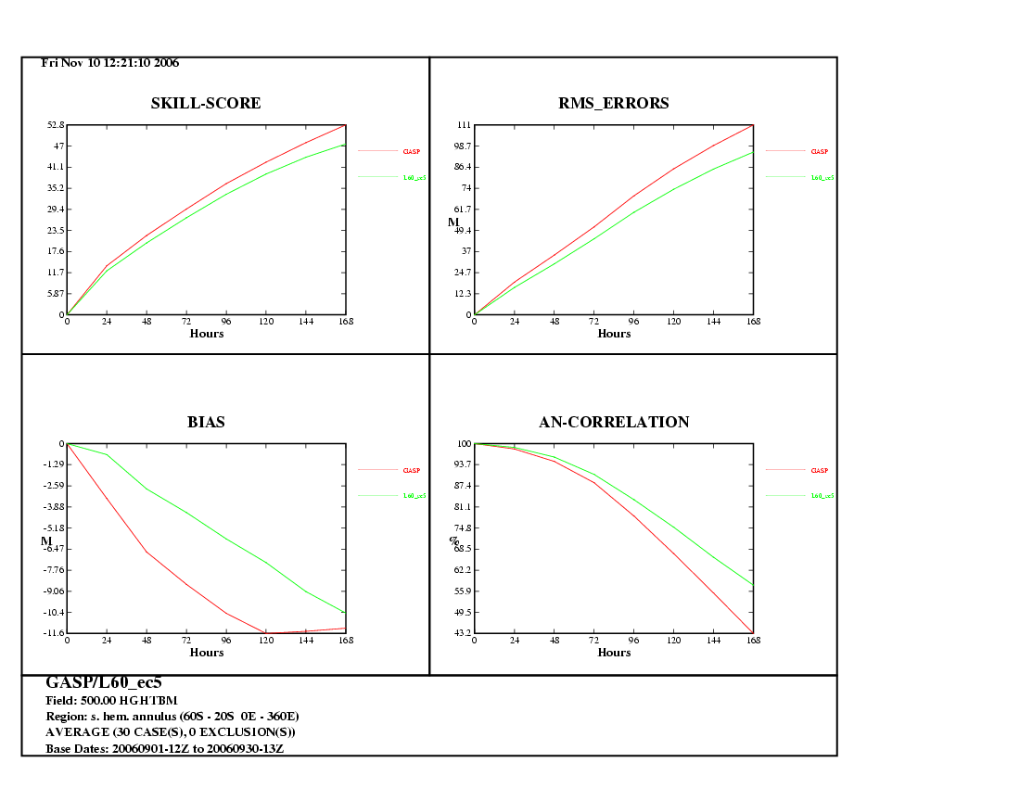
Figure 1: Anomaly Correlation for 500 hPa height over the Southern Hemisphere annulus (60ºS to 20ºS) for September 2006. The lower line is the operational (33 level) system. The upper line is for the 60 level global system with AAPP radiances and 5 satellites.

the resources required to handle the projected increase in the amount of data and the number of space borne sensors.

References
Harris, B. A. and Kelly, G. A. (2001), “A satellite radiance bias correction scheme for data assimilation”, Q. J. R. Met. Soc., 127, 1453-1468.
Kepert, J., Tingwell, C., Tory, K. and Steinle, P. (2005), “Scatterometer Assimilation in the Bureau of Meteorology Numerical Weather Prediction Systems”, BMRC Research Letter, No. 3.
Steinle, P., Paevere, J., Kepert, J., Tingwell, C., Harris, B., Glowacki, T., Davidson, N. and Tory, K. (2004), “Impact of various observing systems on the BMRC NWP systems”, Proceedings of the 3rd WMO workshop on the Impact of Various Observing Systems on Numerical Weather Prediction, Alpbach, Austria, 9-12 March 2004.
Steinle, P. (2005), “Generalized Statistical Interpolation”, Proceedings of the 4th WMO Symposium on the Assimilation of Observations in Meteorology and Oceanography, Prague, 18-22 April 2005.
(B. Harris, P. Steinle and C. Tingwell, Bureau of Meteorology Research Centre, Melbourne, Australia)

Uccellini: Presidential Rank Award and Best Book


Louis Uccellini, Director of NOAA’s National Centers for Environmental Prediction, and Chair of the Management Oversight Board of the JCSDA, was cited for two outstanding achievements during the past quarter. He received a 2006 Presidential Rank Award, and his book Northeast Snowstorms, co-authored with Paul Cocin, was named one of the best ever written on weather.

The Presidential Rank Award honors him for extraordinary leadership qualities and accomplishments, including his role in the 2001 NASA/NOAA effort to create the Joint Center of Satellite Data Assimilation. This enabled NOAA’s National Weather Service to use 190 million satellite observations per day in modeling systems that now routinely predict extreme weather events 3 to 5 days in advance. His work also accelerated the transition of research results into operational forecast systems, contributing to the remarkable predictions for Hurricanes Katrina and Rita. The Presidential Rank Award is presented annually to a small group of career Senior Executives for exceptional long-term accomplishments.

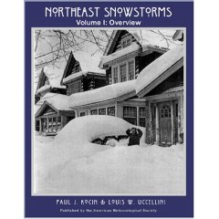
The Wall Street Journal selected Northeast Snowstorms, published by the American Meteorological Society, as one of the five best books ever written on the subject of weather. In its citation, the Journal noted “If there were a gold standard for weather reference books, it would be the two-volume: Northeast Snowstorms. It covers every snowstorm of any significance to affect the Mid-Atlantic and New England regions since the Blizzard of 1888, providing upper-air charts, snowfall maps and even satellite imagery for the more recent storms. It is an extraordinary reference work of any sort but a treasure for anyone who loves snowstorms or weather history.”

Congratulations, Louis.

JCSDA Visitor Implements CRTM in WRF System Data Assimilation System


During his short–term visit to JCSDA in November, Dr. Zhiquan Liu, a Project Scientist from the Mesoscale & Microscale Meteorology Division at the National Center for Atmospheric Research (currently on leave from National Satellite Meteorological Center, Beijing), has implemented JCSDA’s Community Radiative Transfer Model (CRTM) in the Weather and Research Forecasting (WRF) model’s 3/4D-variational data assimilation system (WRF-Var). His stay was the first step of a collaborative effort between the JCSDA and NCAR/MMM to advance satellite data assimilation, particularly for mesoscale applications. The WRF-Var system, like the CRTM, is a community resource, designed both for operational applications (e.g., by the US Air Force Weather Agency, Korea Meteorological Agency, Chinese Beijing Meteorological Bureau, and Taiwanese Central Weather Bureau) and use by the research community. A variety of data assimilation techniques have been developed or are being developed (3DVAR/4DVAR, Ensemble-based Kalman Filter and some hybrid techniques) by the NCAR/MMM Division’s data assimilation group. The ‘marriage’ between CRTM and WRF-Var is expected to widen application capability for both sides. A broader use of CRTM through WRF-Var applications in turn is expected to contribute to the transition from research to operations for satellite data assimilation, thus contributing directly to the JCSDA mission.

Cosmic Corner

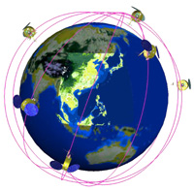
Eight months after launch the Constellation Observing System for Meteorology, Ionosphere, and Climate (COSMIC) is now providing over 1500 quasi-vertical soundings of bending angle and refractivity daily. These are delivered in BUFR code to the JCSDA and preliminary forecast impact assessments of both bending angle and refractivity have been made in the NCEP Global Forecast System using the Gridpoint Statistical Interpolation (GSI) analysis system. Preliminary forecast impact assessments of COSMIC observations in the GFS are promising, particularly near the tropopause where the accuracy and vertical resolution of radio occultation data provide their most significant augmentation to the observing system. It is expected that COSMIC data will be assimilated routinely when the GSI becomes operational.

Several recent meetings have been devoted to the COSMIC mission, and evaluation and exploitation of COSMIC data. These include a workshop and a retreat held in Colorado in October, an international COSMIC Workshop in Taiwan during November, and a session on GPS Radio Occultation at the American Geophysical Union Meeting in December. In addition, Bill Kuo of the University Corporation for Atmospheric Research gave a very comprehensive review of Early Results from the COSMIC/FORMOSAT-3 Mission in the JCSDA Seminar series on Nov.14.
(J. Yoe, JCSDA)

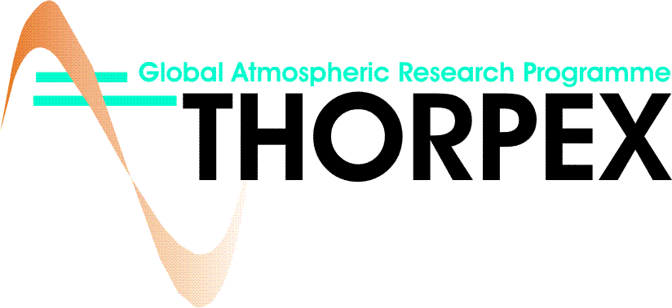
At its latest meeting in November, the US THORPEX Executive Committee (USTEC) reviewed a draft version of the US THORPEX Science Plan developed by the US Science Steering Committee. A revised version of the plan is currently being prepared for broader distribution. Other interagency activities include discussions on the details of the THORPEX Pacific Asian Regional Campaign (T-PARC), currently planned for August to December 2008, in conjunction with the International Polar Year (IPY). Discussions are focused on the contributions by the different agencies and the community to the three main components of T-PARC: tropical cyclones, tropical – extra-tropical interactions, and downstream propagation of disturbances reaching the continental US and the polar region. Internationally, the Second THORPEX Science Symposium was held in December in Landshut, Germany. The meeting brought together more than 150 scientists from around the globe to discuss open science questions related to the prediction of high impact weather in the 1-14 day forecast period and beyond.

Upcoming THORPEX-related meetings of interest:

THORPEX Special Session on “Bridging the studies of weather and climate”, under the AMS Forum: Climate Variations and Change Manifested by Changes in Weather, Wednesday, 17 January 2007, San Antonio, Texas, http://www.ametsoc.org/meet/annual/call.html#weather

THORPEX Town Hall Meeting at the AMS 2007 Annual Meeting, Thursday, 18 January 2007, 12:00–1:30 p.m.; Room 207A, San Antonio, Texas,
http://www.ametsoc.org/meet/annual/programsandevents.html#town

THORPEX session - NP5.04 Predictability of high impact weather (THORPEX) - at the General Assembly of the European Geosciences Union (EGU), Vienna, Austria 15 – 20 April 2007, http://meetings.copernicus.org/egu2007/

THORPEX session - IAMAS Session MS009 “Dynamics and Predictability of Severe Weather Events" at the 24th IUGG Conference in Perugia, Italy, July 2-13 2007
(Zoltan Toth, NCEP)

Uccellini and Einaudi Address Space Business Roundtable
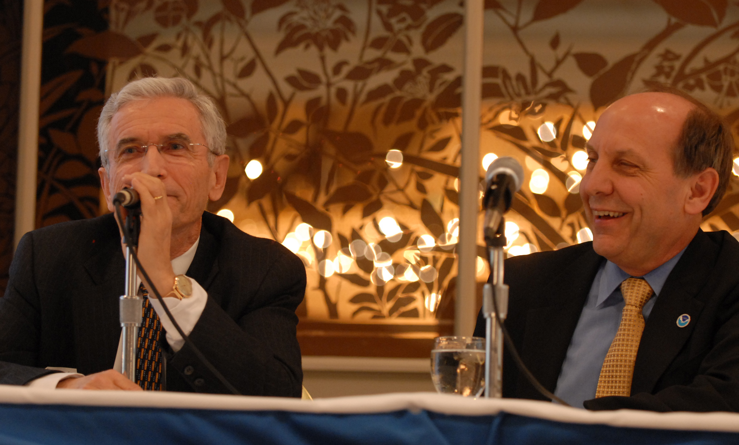
Einaudi (left) and Uccellini enjoy a lighter moment at their presentation to the Space Roundtable
Drs. Louis Uccellini, Director of NOAA’s National Centers for Environmental Prediction, and Franco Einaudi, Director of the Earth-Sun Exploration Division of the Sciences and Exploration Directorate at NASA’s Goddard Space Flight Center, presented a joint talk on Our Nation's Remote Sensing/Modeling: Research to Operations Enterprise to a capacity audience of over 300 at The Maryland Space Business Roundtable on November 28. Uccellini is Chair, and Einaudi a member, of the Management Oversight Board of the JCSDA.
Einaudi described how the traditional emphasis of “research to operations (R2O)” is evolving to one of “research to operations to research.” In the future, an equal partnership can be expected between the research and operational communities, with “research” features being built into operational instruments. Einaudi highlighted recent accomplishments, including observing capability transition, mission extension, data record development and stewardship, data utilization, and tools and standards transition. He reviewed the origin of the JCSDA beginning with the seminal 2000 White Paper, A NASA and NOAA Plan to Maximize the Utilization of Satellite Data to Improve Weather Forecasts, by Einaudi (NASA/GSFC), Uccellini (NOAA/NCEP), Purdom (NOAA/ORA), and MacDonald (NOAA/OAR). He listed the Center’s many significant accomplishments since its inception. Einaudi closed by emphasizing the importance of NASA and NOAA implementing a replacement to the Operational Satellite Improvement Program (OSIP) featuring a planned path for the transition of instruments from research to operations.
Uccellini then presented an operational perspective on the JCSDA. He showed that the five order of magnitude increase in satellite data over ten years (2000-2010) has been tempered by our capacity to use the data, where of the 239.5 million observations received operationally from providers every day, 7% are selected as suitable for use (cloud free, for example), and 2% are actually assimilated into models. He described how observations and modeling systems are now linked in the environmental forecast process, and listed the 35 satellite instruments used in NWP and Climate Prediction. Uccellini then showed how satellite data assimilation is having a major positive impact in model forecast skill, and he echoed Einaudi’s call for a solidified transition process for research instruments to operational deployment.
The Maryland Space Business Roundtable (MSBR) is the only organization dedicated to serving the space related business interests in the state, and encouraging the growth and development of these businesses. The MSBR is composed of 60 small, medium, and large businesses—all with significant connections to NOAA and NASA (www.mdspace.org). The Roundtable sponsors at least 12 events per year, featuring invited government guests and speakers who represent a cross-section of top political, NOAA, NASA, and DOD leaders. A primary goal of the MSBR is to promote educational initiatives that help to build the workforce for tomorrow, especially in the areas of science and technology. In line with this goal, the Roundtable supports multiple diverse educational outreach programs.
(Phil Ardanuy, Raytheon)

Federal Funding Opportunity Update

All of the proposals received by the JCSDA in response to the FY07 FFO announcement passed the Minimum Requirements Review, making them eligible to be peer-reviewed. Each of the 22 proposals has been sent to three qualified evaluators, and all reviews are due by the end of the first week of January 2007. Based on the ranking of the proposals and available funding, a selection package will be submitted to the NOAA Grants Management Division by February 1. Following approval of the selection, each principal investigator will be informed whether his/her proposal: will be funded; may be funded should additional resources become available; or will not be funded. It is intended that successful new investigators will be informed in time to take part in the JCSDA Science Workshop.
(Jim Yoe, JCSDA)

Upcoming Events

JCSDA Science Workshop for 2007

The Annual Science Workshop of the JCSDA will be conducted May 1-3, 2007 in the Washington DC metropolitan area. The specific location will be announced as soon as arrangements have been finalized. Each JCSDA-supported investigator should plan on attending the workshop and presenting an oral progress report. Investigators whose efforts are supported through individual member agencies are strongly encouraged to participate as well. Templates for a single-slide and single-page summary will be distributed by e-mail at least one-month before the Workshop, as well as a complete preliminary agenda. As in 2006, parallel sessions will be minimized to promote interaction between investigators whose work addresses different JCSDA science priority areas.
(Jim Yoe, JCSDA)

JCSDA Workshop on the Application of Remotely Sensed Observations in Data Assimilation
As part of its effort to ensure a sufficient and adequately skilled workforce, the JCSDA will sponsor a Workshop on the Application of Remotely Sensed Observations in Data Assimilation at the University of Maryland, College Park, MD, July 23 – August 10, 2007. The Workshop is being organized and hosted by The Cooperative Institute for Climate Studies, Earth System Science Interdisciplinary Center, and the Department of Atmospheric and Oceanic Science at the University. A range of topics will be covered, including 3D and 4D variational methods, Ensemble Kalman Filtering, Radiative Transfer Models, remote sensing and assimilation of satellite data: AMSU, AIRS, SSM/I and other instruments. The syllabus will include lectures from experts in government and academia and practical exercises for the students. Recent Ph.D. recipients and graduate students at U.S. institutions who will receive their Ph.D. in atmospheric or related sciences prior to June 2008 are encouraged to apply. On campus housing is available and support for travel and living expenses will be provided to participants. Application details are posted on http://www.essic.umd.edu and additional information is
available from Arnold Gruber, agruber@essic.umd.edu or Eugenia Kalnay, ekalnay@atmos.umd.edu
Several hundred copies of the Workshop Announcement will be distributed at the 87th American Meteorology Society (AMS) Annual Meeting in San Antonio, TX, 14 –18 January, 2007. Ken Carey will highlight the workshop in a short introduction to the participants of the 11th Symposium on Integrated Observing and Assimilation Systems for the
Atmosphere, Oceans, and Land Surface (IOAS-AOLS) at the Meeting.

Coastal Ocean Data Assimilation Workshop

A Workshop on Data Assimilation in Support of Coastal Ocean Observing Systems will be held at Oregon State University, Corvallis, on April 3-5, 2007. Under the sponsorship of the NOAA Cooperative Institute for Ocean Satellite Studies (CIOSS), the workshop will bring together experts in coastal ocean modeling, data assimilation (DA), and satellite data analysis, with the charge to assess the present status of modeling and DA in the coastal ocean and to identify directions for future research. Participants will review the theory and implementation of advanced DA methods, exchange information on DA activities in recently funded National Oceanographic Partnership Program -
Global Ocean Data Assimilation Experiment ( NOPP-CODAE) projects, and discuss opportunities for assimilation of satellite (versus other available) observations in coastal ocean models. The program will include invited talks, contributed posters, and discussions.

Satellite-derived oceanic information (e.g., Sea surface Height and Sea surface Temperature) has been limited in shelf areas because of insufficient spatial and temporal resolution, clouds, and problems deciphering the electromagnetic signal in the 25-50 km zone near the coast. Near real-time coastal ocean models should help improve the utility of observations, providing time- and space-continuous information on the origin and evolution of dynamical structures apparent in the observations. Data assimilation (DA) in the circulation models will provide new tools for data mapping and synthesis, oceanographic analysis, and for designing optimal observational arrays. DA will be used to identify dominant error sources in the models and verify statistical hypotheses about the ocean.

The workshop is open to all interested participants, limited only by space availability (50 people). It is anticipated that limited travel support will be available through CIOSS.
Please address your inquiries to the organizing committee:
Alexander Kurapov: kurapov@coas.oregonstate.edu, 541-737-2865
John S. Allen: jallen@coas.oregonstate.edu
P. Ted Strub: tstrub@coas.oregonstate.edu
(Eric Bayler, JCSDA)

Lidar Winds Group

The next meeting of the Working Group on Space-Based Lidar Winds will be held in Miami, Florida, on February 6 - 9, 2007.

(Wayman Baker, JCSDA)

Date | Speaker | Agency | Subject
1/31/07 | Dale Barker | UCAR | Hybrid Variational/Ensemble Data Assimilation in WRF
3/21/07 | Paul Chang & Zorana Jelenak | NOAA | Overview and Validation of Changes in the Near Real-Time QuikSCAT Processing
4/18/07 | William Bell | UK Met Office | The European Satellite Applications Facility for NWP

Upcoming JCSDA Seminars

Suggestions for speakers and topics are always welcome; please send them to george.ohring@noaa.gov.

Please submit news items 2 weeks prior to the end of each quarter to george.ohring @noaa.gov

