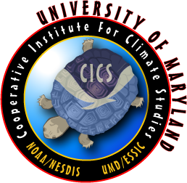
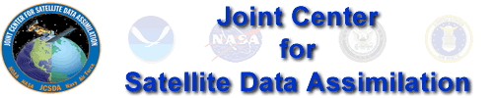

Workshop Announcement
Application of Remotely Sensed Observations in Data Assimilation
July 23- August 10, 2007 at the University of Maryland in College Park

Second Announcement and Deadline Extension to February 15, 2007

The Cooperative Institute for Climate Studies, Earth System Science Interdisciplinary Center, and the Department of Atmospheric and Oceanic Science at the University of Maryland, and the Joint Center for Satellite Data Assimilation (JCSDA) are pleased to announce a three week summer workshop on the Application of Remotely Sensed Observations in Data Assimilation. The JCSDA is sponsored by the National Oceanic and Atmospheric Administration, the National Aeronautics and Space Administration and the Department of Defense. The Workshop will be held July 23- August 10, 2007 at the University of Maryland. A range of topics will be covered including 3D and 4D variational methods, Ensemble Kalman Filtering, Radiative Transfer Models, remote sensing and assimilation of satellite data; AMSU, AIRS, SSM/I and other instruments. The syllabus will include lectures from experts in government and academia and practical exercises for the students.

Eligibility: Recent Ph.D. recipients and graduate students at U.S. institutions who will receive their Ph.D. in atmospheric or related sciences* prior to June 2008. On campus housing is available and support for travel and living expenses will be provided to participants.

We seek applicants from graduate students nearing the completion of their Ph. D. and recent post doctorates to participate in this workshop. Applicants should include their transcript, a brief curriculum vitae, a 1-page description of their thesis research and their interest in this Workshop, and a letter supporting their nomination from their thesis advisor. This information should be forwarded as e-mail attachments to Tammy Barksdale, tammy@atmos.umd.edu before 15 February 2007. We will inform candidates about the disposition of their applications before 15 March 2007. This announcement is also posted on www.essic.umd.edu

For more information about the Workshop contact Arnold Gruber, agruber@essic.umd.edu or Eugenia Kalnay, ekalnay@atmos.umd.edu.

* These include programs such as Atmospheric and Ocean Dynamics, Atmospheric Chemistry and Biogeochemistry, Mesoscale Meteorology, Weather Prediction, Climate Science and Global Change, Atmospheric Physics, Computational Sciences, Applied Mathematics, and Numerical Methods.

