News in This Quarter

Navy Begins Operational Assimilation of Direct Broadcast MODIS Winds

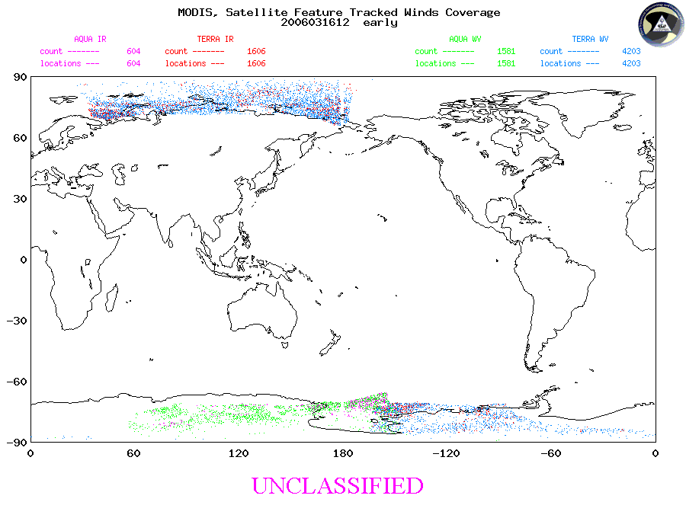
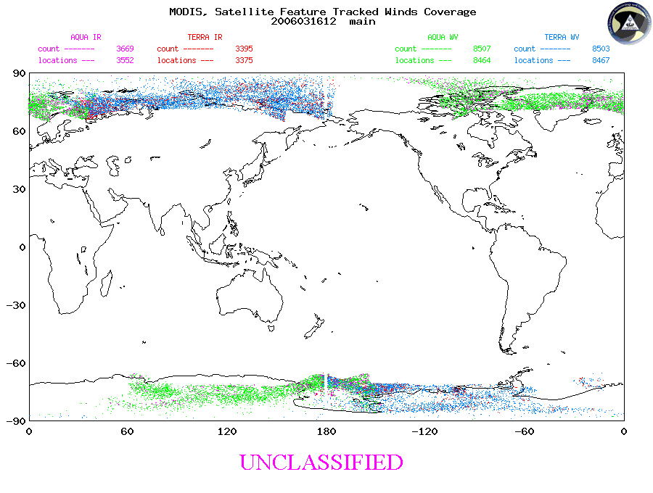
MODIS winds available for the early NOGAPS model run (top) and for the main run (bottom). Both the McMurdo direct broadcast and bent-pipe wind data sources are included in both cases. Wind sources - Green: Aqua water vapor; Blue: Terra water vapor; Pink: Aqua IR; Red: Terra IR
Eight numerical weather prediction (NWP) centers worldwide are assimilating the Moderate Resolution Imaging Spectroradiometer (MODIS) polar winds in their operational forecast systems. However, typical delays in acquiring the MODIS data are such that much of the wind information is not available in time to be used in operational production runs of NWP models. To provide the MODIS winds in a more timely manner, direct broadcast (DB) MODIS data are being exploited. There are well over 100 DB sites worldwide. These sites receive data directly from NASA’s Terra and, in some cases, Aqua satellites as they pass overhead.

In early 2005, the National Science Foundation (NSF) installed a satellite antenna at McMurdo, Antarctica, for the purpose of utilizing Terra and Aqua direct broadcast data, primarily MODIS imagery. Since March 2005 polar wind data covering much of Antarctica have been generated in real-time. The DB winds can be generated at least one hour faster than with our current data source, making more winds available for weather forecast models.

After nearly a year of testing and validation, the McMurdo DB winds are being made available to the NWP community. In addition to being posted on a public FTP site, the wind data are “pushed” to the Fleet Numerical Meteorology and Oceangraphy Center (FNMOC) for use in NOGAPS (Navy Operational Global Atmospheric Prediction System). Operational assimilation of McMurdo DB winds into NOGAPS began on 15 March 2006. NAVDAS (NRL Atmospheric Variational Data Assimilation System), the analysis component of NOGAPS, employs superobbing of MODIS winds. The McMurdo direct broadcast winds are superobbed together with the previously operational “bent-pipe” MODIS winds. Observation versus model background statistics for the DB winds in NAVDAS appear comparable to the bent-pipe winds.

The figure illustrates the data availability for the early and main NOGAPS model runs from 12Z on 16 March 2006. The early run has a data cutoff of +1:10 (one hour and ten minutes after the synoptic hour); the main run has a cutoff of +3:10. Both MODIS wind data sources are shown. In this instance all of the Antarctic winds for the early run and >80% of the Antarctic winds for the main run are from McMurdo.

With the early success of the McMurdo system, additional sites in the Arctic and Antarctic are being explored. A system is currently being installed in Tromsø, Norway that is tentatively planned to utilize an Integrated Program Office antenna on Svalbard. Another system is being configured for Sodankylä, Finland. Discussions are underway for similar systems in Fairbanks, Alaska, and Troll, Antarctica (Norway).

More information on the direct broadcast winds and other products is available at http://stratus.ssec.wisc.edu/products/db.
(R. Pauley, FNMOC, and J. Key, NESDIS)

International Items:
Data Assimilation at the Meteorological Service of Canada

Since March 2005, the Meteorological Service of Canada (MSC) has operated a global 4D-Var data assimilation system (DAS) to provide initial conditions for 10-day deterministic forecasts. A major upgrade in horizontal resolution is planned for June 2006. The current grid of 400 x 200 (~100 km) will increase to 800 x 600 (~33 km), with 58 vertical levels instead of 28. The model top remains at 10 hPa and the inner loop still uses a 240 x 120 grid. A regional DAS provides analyses at 15 km resolution over Canada and most of the US. An ensemble Kalman filter DAS with 96 members was implemented in January 2005 to provide an ensemble of initial conditions for the global ensemble prediction system (currently 16 members). Another major activity is the development of a chemical DAS which includes the stratosphere.


ATOVS radiances are assimilated directly using the RTTOV radiative transfer model. AMSU-A radiances from NOAA15-16-18 and AQUA are assimilated (typically channels 3-10 over oceans and 6-10 over land). AMSU-B radiances from NOAA15-16-17 and MHS radiances from NOAA-18 are assimilated for channels 2-5 over oceans and 3-4 over land. GOES-10 and 12 Imager 3 radiances (water vapor channel) are assimilated at 3-h intervals. Atmospheric motion winds estimated from the two GOES satellites, Meteosat 5 and 8 and MTSAT-1R are also assimilated as well as MODIS-derived winds from AQUA and TERRA over Polar Regions. Wind profiler data from the US network are also part of the list of remote sensing data used operationally. A significant input of new data is planned for late 2006. These include radiances from the 7 SSM/I channels from DMSP-13-14-15, hourly assimilation of GOES Imager 3, and 100 AIRS channels (4.0-14.5 μm). Fig. 1 shows the impact of AIRS obtained in 3D and 4D- Var cycles. The combined impact of 4D-Var + AIRS represents a gain in predictability of the order of 10 hours at day 5 in the Southern Hemisphere.

In 2007, MSC will be ready to directly assimilate COSMIC occultation data (refractivity profiles). Tests made with CHAMP data are promising, leading to improved temperature fields. IASI data from METOP should also be assimilated next year, using a subset of the order of a few hundred channels. The impact of directly assimilating GPS zenith tropospheric delay (ZTD) on moisture analyses is being tested in the regional DAS using NOAA/ESRL observations. Quikscat backscatter will also be assimilated over open oceans and an approach for the assimilation of passive


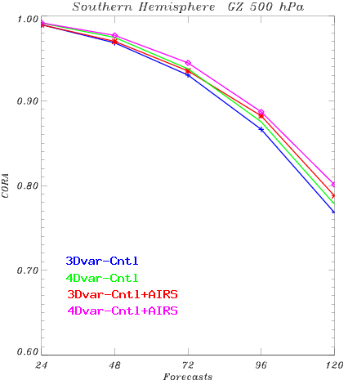
500 hPa geopotential anomaly correlation in the Southern Hemisphere for forecasts up to 5 days (120 hr). CONTROL (CNTL) uses all data except AIRS. The +AIRS cycles use 100 channels. Period: 14-25 February 2004.

microwave radiances in rainy conditions is being developed. By 2008, the operational model top will be raised to 0.1 or 0.01 hPa, allowing stratospheric analysis of various species.
(L. Garand, MSC)

Cosmic Corner: COSMIC Successfully Launched

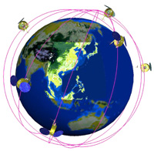
The Constellation of Satellites for Meteorology, Ionosphere, and Climate (COSMIC) was successfully launched from Vandenberg Air Force Base on Friday, April 14. All 6 COSMIC satellites are in radio communication with ground stations and checkout is underway. The JCSDA expects to be receiving occultation data as soon as the first ones are available.
A preliminary assessment by Lidia Cucurull and JCSDA colleagues of GPS radio occultation (GPSRO) data provided by the CHAMP instrument has shown some positive impact in temperature analyses and forecasts, especially near 200 hPa. Both refractivity and bending angle have been successfully assimilated, and the coming months will see a flurry of activity dedicated to refining this work, improving quality control and error characterization, and using COSMIC observations as well as CHAMP.
On April 6 Jim Yoe gave an invited presentation on GPSRO to the Board for Atmospheric Science and Climate (BASC) at the National Academy of Sciences in Washington, D.C. The application of GPSRO to numerical weather prediction, climate monitoring, and satellite product verification was well received, particularly with the launch of COSMIC only a week in the future.
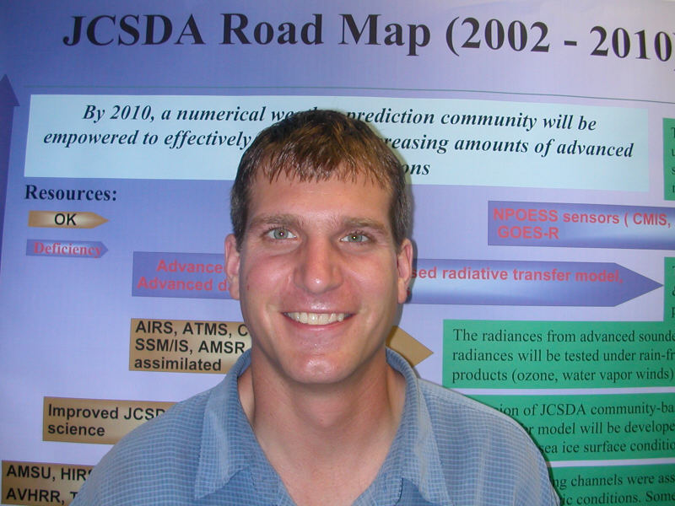
(Jim Yoe, JCSDA)

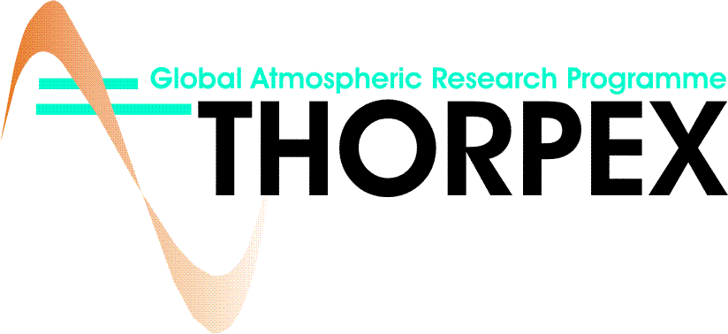
The THORPEX International Working Groups (WG) and Advisory Panels met at a joint meeting during the week of 20-24 March 2006. Some of the WGs have been active in holding prior meetings and setting up research interest and discussion groups, including some related to satellite data assimilation, and in preparing for the establishment of an international global ensemble forecast archive (THORPEX Interactive Grand Global Ensemble, TIGGE). If you are interested joining these activities, contact and other information can be found at: http://www.wmo.int/thorpex/. Meanwhile, the THORPEX North American Regional Committee has been developing plans for the Pacific Asian Regional Campaign (PARC), to be held in August-December 2008, in conjunction with the International Polar Year (IPY). For further information on this, see: http://www.ucar.edu/na-thorpex/. On the national level, a US THORPEX Program Office is being set up with contributions from various agencies (currently the National Science Foundation, NSF, and NOAA, with advice from NASA and ONR), and the US THORPEX Science Steering Committee is being reconstituted. Note that the Second International THORPEX Science Symposium is scheduled to take place in Landshut, Germany, between 4-8 December, 2006.
(Z. Toth, NCEP)

25th Meeting of the Working Group on Space-Based Lidar Winds

Approximately 40 U.S. and European scientists and lidar specialists attended the 25th meeting of the Working Group on Space-Based Lidar Winds (Lidar Working Group), held in Key West, Florida, January 17 - 20, 2006. Some of the meeting highlights were: presentations on the status of ESA's Atmospheric Dynamics Mission, which will be the first wind lidar flown in space and scheduled for launch in late 2008; the first forecast impact test with actual wind lidar data, measured by aircraft, with a significant positive impact obtained with the ECMWF forecast system; and scientific presentations on the importance of global tropospheric winds for investigations of CO2 sources and sinks, and for the hydrologic cycle. The next Lidar Working Group meeting is scheduled for June 27 - 30, 2006, in Welches, Oregon.
(W. Baker, JCSDA)

NRL Personnel Notes

Dr. Benjamin Ruston has accepted a civil service position at the Naval Research Laboratory (NRL), Monterey, following his 2-year tenure there as a National Research Council postdoctoral fellow. During his fellowship, Dr. Ruston was funded by the JCSDA to conduct research on the assimilation of passive microwave radiances over land, using the JCSDA common Microwave Emissivity Model (MEM) in complex terrain regions. As a member of NRL's Data Assimilation Section, Dr. Ruston will continue to contribute to the goals of the JCSDA and to the operational assimilation of satellite data by the U.S. Navy.


Dr. Patricia Pauley, NRL Monterey, has been selected to receive a Purdue University Department of Earth and Atmospheric Sciences Outstanding Alumnus Award. Dr. Pauley, a graduate of Purdue University, has contributed to the goals of the JCSDA over the past few years through her work in assimilating satellite wind observations, including feature-tracked winds from geostationary and polar-orbiting satellites and marine surface winds from SSM/I, QuikSCAT, ERS-2, and WINDSAT. Fleet Numerical Meteorology and Oceanography Center was the first NWP center in the U.S. to operationally assimilate feature-tracked winds from MODIS.



Meet Peiming Dong

Dr. Peiming Dong has joined the Satellite Meteorology and Climatology Division, Center for Satellite Applications and Research (STAR), NESDIS, for a six month visit. Dr. Dong will be working on improving satellite data assimilation schemes over land through better uses of NWP model output on land surface properties and improved infrared and microwave emissivity models. Dr. Dong is a key research scientist from the Chinese Academy of Meteorological Science, Chinese Meteorological Administration (CMA), on developments of the Chinese Global and Regional Assimilation and PrEdiction System (GRAPES). Currently, GRAPES has an interface with RTTOVS, a radiative transfer model developed by the Met Office and ECMWF. CMA is also studying the possibility of implementing into GRAPES the community radiative transfer model (CRTM) developed by the JCSDA. Dr. Dong’s visit will foster a strong collaboration in satellite data assimilation between CMA and NESDIS.



Meet Yong Chen

Dr. Yong Chen has joined the JCSDA as a Visiting Scientist to work on the JCSDA community radiative transfer model (CRTM). Dr. Chen recently graduated from University of California, Los Angeles, with a PhD in atmospheric sciences. His dissertation title is "Three-Dimensional Monte Carlo and Diffusion Radiative Transfer Models Applied to Inhomogeneous Clouds and Surfaces” which was supervised by Professor Kuo-Nan Liou. He has published several peer-review articles including an efficient 3D IR and solar radiative transfer parameterization based on diffusion approximation for cloudy atmospheres, a 3D IR Monte Carlo model for specific application to the broadband thermal radiative transfer for cloudy atmospheres, and remote sensing of 3D structure of cirrus clouds using combined AVHRR IR window band imager data with vertical pointing mm-wave radar time series. Dr. Chen's primary responsibility at the JCSDA will be the development of various CRTM components and validation of the CRTM.

Windsat

Scientists from the Joint Center for Satellite Data Assimilation, The Cooperative Institute for Meteorological Satellite Studies and the University of Wisconsin are assimilating Windsat Data into a version of Operational Global Data Assimilation System in a study to quantify the utility of these data for operational NWP. The initial experiments have involved the use of Windsat Wind Vectors and these are currently being assessed in terms of the assimilation methodology, their benefit to the current operational systems and in comparison to QuikSCAT. It is intended to assimilate radiances as the next step in this experiment.

Outlook for Next Quarter

Upcoming JCSDA Seminars

4/19/06 | Roger Saunders | UK Met Office | The Exploitation of Satellite Data at the UK Met Office
5/15/06 | Oliver Reitebuch | German Aerospace Center | Lidar Winds
5/17/06 | Jim Hansen | MIT | Assimilating Satellite Data to Aid in the Initialization of Localized Phenomena

Suggestions for speakers and topics are always welcome; please send them to george.ohring@noaa.gov.

1st Workshop on Remote Sensing
and Modeling of Surface Properties

20-22 June 2006, Paris, France

The 1st Workshop on Remote Sensing and Modeling of Surface Properties will focus on remote sensing and modeling of radiometric and geophysical surface properties, including the impacts of assimilating surface-sensitive measurements.
Microwave and infrared spectra, and all surface types are of interest: ocean, land, snow, and ice. The workshop is an activity of the International TOVS Working Group and is sponsored by the Paris Observatory and the Satellite Meteorology and Climatology Division of the NOAA/NESDIS Office of Research and Applications.
(F. Weng, NESDIS)

Upcoming JCSDA Events:
- Annual Science Review Workshop, May 31-June 1, 2006
Please submit news items 2 weeks prior to the end of each quarter to george.ohring @noaa.gov

Please submit news items 2 weeks prior to the end of each quarter to george.ohring @noaa.gov

