Biosphere-Atmosphere Research & Training (BART)
Technical Short Course Information – Summer 2006
Technical short courses will provide hands-on technical training to graduate students, postdoctoral scholars, faculty members, and scientists. Each course will provide participants with the tools necessary to conduct research in a particular subdiscipline of biosphere-atmosphere interactions.
The technical short courses will be offered over a five-day period at the University of Michigan’s Biological Station (UMBS), an outstanding venue for technical courses of many kinds, with extensive classroom, computing, and laboratory facilities. The University of Michigan Biological Station is located at the northern tip of the
Lower Peninsula of Michigan, on the south shore of Douglas Lake.
The cost for a five-day technical short course is $1200 (includes lodging and dining for six days, as well as facility and lab fees for five days). For more information, contact the BART office at 888-647-0536, bartumbs@umich.edu, in Ann Arbor. Full course descriptions and registration forms are also available at our website, www.lsa.umich.edu/umbs/bart.

Plant Physiological Ecology
June 24-30, 2006
A technical short course in key ecophysical methods, predicated on the concept that plants mediate aspects of mass and energy exchanges between ecosystems and the atmosphere. Topics covered include gas exchange, water relations, root dynamics, and stable isotopes.

Flux Measurement Fundamentals
July 9-15, 2006
A technical short course in the use of micrometeorological methods to obtain and analyze fluxes of momentum, heat, and chemical species by eddy-covariance, eddy accumulation and related techniques. Topics covered include theory of turbulent exchange measurements, flux measurement techniques, installation and operation of an EC and energy balance measurement site, and QA/QC.

Please bring your own bedding (including pillows) and towels. We will send a more detailed list of items and general information about UMBS along with confirmation of your registration. Please do not bring pets.
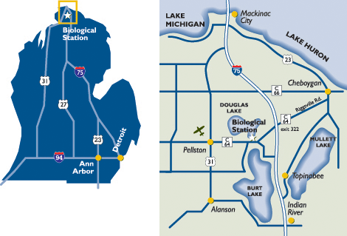

Biosphere-Atmosphere Research & Training (BART)
Technical Short Course Registration 2006

_____ Plant Physiological Ecology _____ Flux Measurement Fundamentals
June 24-30, 2006 July 9-15, 2006

Check the course(s) in which you wish to enroll. Cost is $1200 per course or $2160 for two.

Participant contact information
Name

Address

City/State/Zip

Phone Email

Payment information
You may pay either by check or by credit card. If paying by check, send your deposit of $150 per course and registration form to: BART, University of Michigan, 830 N. University Avenue, 2014 Natural Sciences Bldg., Ann Arbor, MI 48109-1048. The deposit is non-refundable in the event of your cancellation. The balance of your fees will be due one month prior to the start of your short course. If paying by credit card (Visa or Mastercard only), complete the following information and either submit online or print the form and fax it to 888-647-0536. Registration must be received by May 1 and will be accepted on a first-come, first-served basis; registrations after that time will be accepted on a space-available basis.

Payment method: _____ Check _____ Credit card (see below)
Credit card type: ______ Visa ______ Mastercard
Credit card number: Expiration date:
Printed name on card:
Signature:

Please indicate your roommate preferences. (circle only one)
smoking non-smoking

Please indicate food preferences and/or allergies. (circle all that apply)
vegetarian omnivore no red meat, chicken, fish allergies?_________________

Please list the make, model, color, and license # of the vehicle you will be bringing to UMBS.

Emergency contact information
Name

Address

City/State/Zip

Phone Email

Send your registration and deposit of $150 per course by May 1, 2006, to:

BART Program
University of Michigan
830 N. University Avenue
2014 Natural Science Bldg.
Ann Arbor, MI 48109-1048

Fax to:
888-647-0536

