News in This Quarter

US Department of Commerce Awards Gold Medal to NOAA AIRS/AMSU Team
Left to right: Secretary of Commerce Carlos M. Gutierrez, Award Recipients Russ Treadon, John Derber, Larry McMillin, Fuzhong Weng, and Mitch Goldberg, NOAA Administrator Conrad Lautenbacher, and Deputy Secretary of Commerce David A. Sampson.

The NOAA AIRS/AMSU Team – Mitch Goldberg, Fuzhong Weng, and Larry McMillin of the National Environmental Satellite, Data, and Information Service and John Derber and Russ Treadon of the National Weather Service – received the Department of Commerce’s Gold Medal at a special ceremony in Washington, DC, on December 6, 2005. The Team was cited for developing techniques to assimilate advanced satellite observations into computerized models that significantly improve weather forecasting. The Team worked together on JCSDA’s projects to assimilate the data from the NASA AIRS instrument and to improve the assimilation of AMSU observations over land surfaces. The Gold Medal is the Department of Commerce’s highest award and recognizes distinguished performance characterized by extraordinary, notable or prestigious contributions that impact the Department's mission.

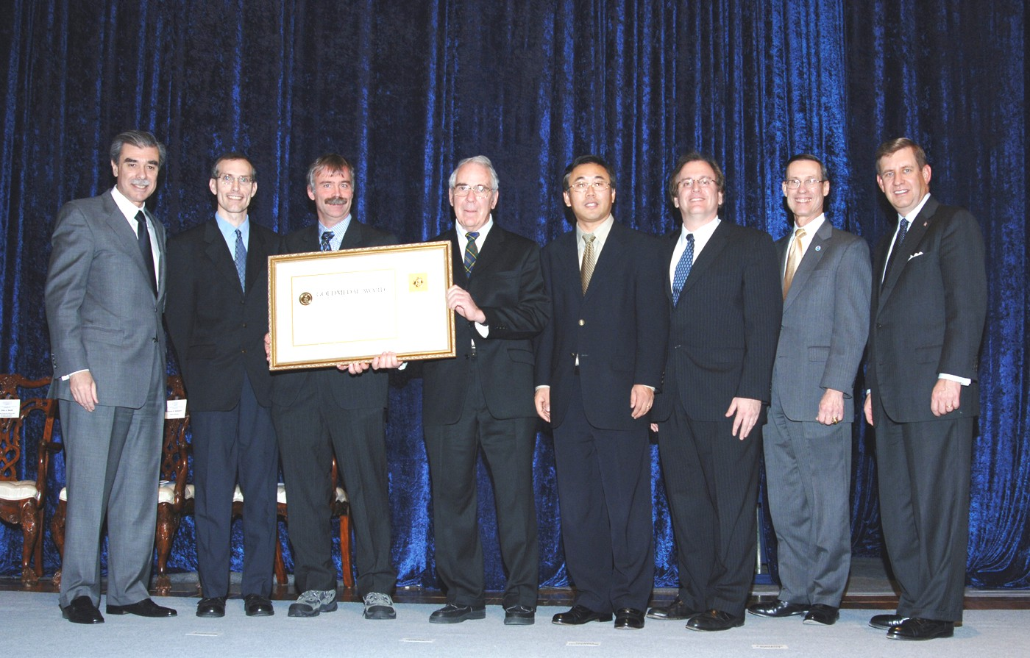

In Memoriam

It is with great sadness that we report the death of Dr. Guy Rochard of Meteo-France early in December, 2005. Guy was an esteemed and beloved member of the international satellite remote sensing community. His efforts in the 1970s to obtain and use NOAA satellite data in France were productive and helped lead to increased international environmental satellite data sharing and exploitation. He was active in the International TOVS Working Group and served as its co-Chair from 1998 to 2003. He worked diligently to protect the microwave sounding and imaging spectrum from radio frequency interference by rallying the scientific community and bringing the issue to the attention of radio spectrum managers throughout the world at every opportunity. His skill, dedication, and good humor will be sorely missed by all who worked with him and knew him. Farewell, Guy.

Science Update: JCSDA Advances Community-Based Systems

NASA’s Global Modeling and Assimilation Office has launched the initial version of its new GEOS-5 assimilation system in parallel test mode. This system is the prototype of a next generation assimilation system based on the Gridpoint Statistical Interpolation (GSI) analysis code being developed jointly by NOAA’s National Centers for Environmental Prediction (NCEP) and GMAO. Basing their operational and research data assimilation systems on a joint analysis code will greatly facilitate the transfer of research results and data from NASA to NOAA and will enable the collaboration between NCEP and GMAO on a wide range of topics, including Observing System Simulation Experiments (OSSEs).

One of the important innovative features of the new analysis code is its flexibility in the prescription of background error statistics. It is believed that this flexibility – once it is fully exploited – will enable us to significantly improve the use of satellite data in the assimilation. Work is now being undertaken to tune the error statistics to the GEOS-5 forecast model. A full suite of data denial experiments will be launched as soon as the tuning of the statistics is completed, and experiments aimed at clarifying the respective contributions to skill of MODIS cloud track vs. water vapor winds and of testing different approaches to data selection for

AIRS will follow in short order. The new analysis system joins the Community Radiative Transfer Model (CRTM) as a contribution to commonality of systems at the JCSDA.
(Lars-Peter Riishojgaard, NASA/GMAO)

International Items:

Data Assimilation at the Japan Meteorological Agency

The Japan Meteorological Agency (JMA) operates three data assimilation systems (DAS) for NWP: global DAS, regional DAS and meso-scale DAS. They are all based on incremental 4D-Var with horizontal resolutions for outer (inner) loop of TL319 (T63), 20 km (40 km), and 10 km (20 km), respectively. The 4D-Var system was implemented in March 2001 for meso-scale DAS, June 2003 for regional DAS and February 2005 for global DAS. Because the regional analysis/forecast system will be merged into a global system with 20 km resolution in 2007, satellite data assimilation for the meso-scale DAS and global DAS are described here.

The meso-scale DAS covers Japan and surrounding oceans. Since accurate rain forecasts require high-quality analyses of moisture, assimilating microwave radiometer (MWR) observations of rain-rate and total column water vapor (TCWV) plays an important role (see Fig.1). The assimilation of SSMI/DMSP-13, -14, -15 and TMI/TRMM data began in October 2003, and AMSR-E/Aqua data in November 2004. ATOVS temperature profiles retrieved by NESDIS and JMA are assimilated in the meso-scale DAS. The direct assimilation of ATOVS radiances is being developed. The 6-hourly winds from tracking water vapor and cloud features observed by Japan’s Multi-functional Transport Satellite-1 Replacement (MTSAT-1R) have been assimilated since June 2005. JMA also generates hourly winds with Quality Indicators in the Northern Hemisphere, and is studying their accuracy and impacts on NWP. In experiments with the meso-scale DAS, sea-surface winds from Seawinds/QuikSCAT improved the prediction of rain and wind sheer over the ocean, resulting in operational use in July 2004.

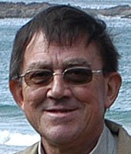

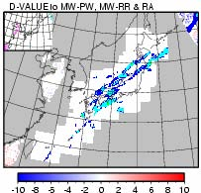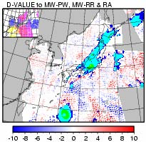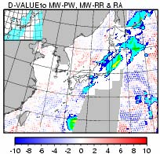
(a) (b) (c)

Fig.1: Rain-rate (colored areas) and Total Column Water Vapor (TCWV) departure from first-guess (dots), used in the meso-scale DAS on 15 Oct 2005. (a) At 06 UTC almost no microwave data are available and the only rain data are from the ground based radar network (white area). (b) At 12 UTC three SSM/I instruments and one TMI cover a wide area and complement moisture information around Japan beyond the radar range. (c) At 18 UTC AMSR-E provides moisture information to the east and southwest of Japan. Color scales are at bottom of figures.

The global DAS assimilates radiances from AMSU-A/-B on board NOAA-15, -16, -17 and NASA’s Aqua. The assimilation of HIRS data was discontinued in December 2004 because of a cloud detection problem. Despite the suspension of HIRS use, the AMSU-A/-B radiance assimilation improved forecasts in the Southern Hemisphere and high latitudes of the Northern Hemisphere. A thinning scheme with six 1-hour time slots suitable for the 4DVar system, rather than the single 6-hour time slot used in 3D Var, makes more ATOVS available and improves global forecast skills. It became operational in August 2005. The use of MODIS polar winds from Aqua and Terra became operational in May and September 2004 in the Northern Hemisphere and Southern Hemisphere, respectively, as a result of the finding that they reduced forecast errors of the geopotential height in the extratropics. Winds from geostationary satellites, including MTSAT-1R, and surface winds over the ocean from Seawinds/QuikSCAT are assimilated, and current efforts focus on improving the thinning method. As of 2005, neither microwave radiances nor TCWV retrievals are assimilated in the global DAS despite positive impacts in the Southern Hemisphere and the tropics
-- especially in reducing typhoon track prediction errors -because the microwave radiances led to slightly negative impacts in the Northern Hemisphere. We are reviewing QC procedures for MWR data and improving the bias correction by replacing the current static approach with an adaptive one using a variational scheme.

Other work is in progress or planned to assimilate BUFR winds from MTSAT-1R, Meteosat-8 and GOES-10/-12, refractivity data from GPS occultations, TCWV from ground based GPS receivers, clear sky radiances from water vapor channels of geostationary satellites, including MTSAT-1R, radiances from advanced sounders such as AIRS, IASI and CrIS, and cloud/rain affected observations, starting with comparing MTSAT-1R and HIRS radiances with simulations.
(Kozo Okamoto, JMA)

Special Sensor Microwave Imager/Sounder (SSMIS) Workshop

Scientists from the US, Canada, and Europe participated in a workshop at the Naval Research Laboratory’s Marine Meteorology Division in Monterey, California, to discuss recent progress towards assimilating radiances from the SSMIS into operational numerical weather prediction (NWP) data assimilation systems. The main focus of the meeting was to describe, present methods to identify, and recommend correction strategies for the removal or mitigation of the SSMIS calibration anomalies in order to provide quality microwave radiances to the radiance assimilation community.
The consensus of the workshop participants was that 1) the anomaly correction algorithms should be objective, rather than being driven by the NWP model output that defines the radiance biases; and 2) the correction algorithm should be run and maintained at a central location such as NESDIS or the Fleet Numerical Meteorology and Oceanography Center.

The SSMIS is the first of five sensors planned to operate onboard the Defense Meteorological Satellite Program's (DMSP) F-16 through F-20 spacecraft. The participants included scientists from NRL, NOAA, JCSDA, United Kingdom Met-Office (UKMO), European Centre for Medium-Range Weather Forecasts (ECMWF), Navy Fleet Numerical Oceanography Center (FNMOC), Meteorological Service of Canada (MSC), and the Aerospace Corporation. The workshop was sponsored by the Joint Center for Satellite Data Assimilation (JCSDA) and hosted by NRL.
(Nancy Baker, NRL, and Fuzhong Weng, NESDIS)

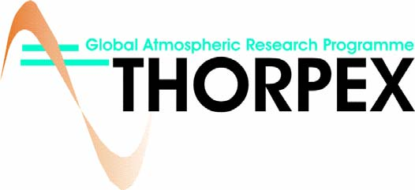

The Fifth meeting of the THORPEX International Core Steering Committee (ICSC) was convened in Melbourne, Australia, November 30 – December 2, 2005. At the meeting, David Burridge, Director of the International Program Office (IPO) and Chair of the Executive Board (EB), along with other participants reviewed developments since the last ICSC meeting. Of notable interest were developments toward the establishment of archives for the THORPEX Interactive Grand Global Ensemble, containing ensemble data collected from various Numerical Weather Prediction (NWP) centers. The archives, to be housed at ECMWF, NCAR, and the Chinese Meteorological Agency (CMA), are expected to become functional in 2006. The ICSC, chaired by Michel Beland of the Meteorological Service of Canada, provided guidance to the EB on THORPEX activities in the coming year. Further details on international activities can be found at: http://www.wmo.int/thorpex/, while information on North American and US developments, including planning for a Pacific-Asian Regional Campaign (PARC), can be found at: http://www.ucar.edu/na-thorpex/.
(Zoltan Toth, NWS)

Meet Wayman Baker

Dr. Wayman Baker joined the JCSDA as Chief Administrative Officer in December 2005 and comes to the JCSDA with 26 years of Federal management experience in both research and operational numerical weather prediction at NASA and NOAA.

Dr. Baker completed his PhD in atmospheric science at the University of Missouri in 1978 before joining NASA’s Goddard Space Flight Center as a research meteorologist later that year. In 1988, he became Deputy Director of NOAA/NWS NCEP’s Environmental Modeling Center (Development Division at that time), and beginning in 1993, Dr. Baker served for 12 years as Deputy Director of NCEP’s Central Operations.

Dr. Baker has been a strong advocate of deploying a Doppler wind lidar in space in order to improve the initial analyses for numerical weather forecasts and has chaired the Working Group for Space-Based Lidar Winds since 1994. He resides in Laurel, Maryland with his wife and two sons.

Cosmic Corner

The Constellation of Satellites for Meteorology, Ionosphere, and Climate (COSMIC) is scheduled to be launched at the end of March, 2006. At the JCSDA Lidia Cucurull has completed coding and testing of the forward, adjoint, and tangent linear operators for both refractivity and bending angle data derived from GPS radio occultation soundings. Impact assessments of CHAMP data in the NCEP analysis and global forecast systems are now underway to prepare for using the COSMIC data stream. Martin Lohmann continues to refine error estimation and algorithms for the GPSRO data products. Lidia and Martin reported on their work at the COSMIC retreat in Colorado in October, 2005. A Mission Readiness Review involving the National Space Agency of Taiwan, the University Corporation for Atmospheric Research, the United States Air Force, and COSMIC data users representing several U.S. government agencies is being planned for January, 2006.
(Jim Yoe, NESDIS)

FY2006 JCSDA Federal Funding Opportunity Status

The Announcement of the JCSDA Federal Funding Opportunity (FFO) for external research for FY 2006 yielded 32 Letters of Intent and subsequently 23 full proposals, of which 18 were compliant and eligible for peer review. The peer review process is expected to be completed and the selected projects submitted to the NOAA Grants Management Office in February. The Principal Investigators who prepared successful proposals and their host institutions will be informed as funding is made available to support their projects.
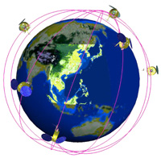
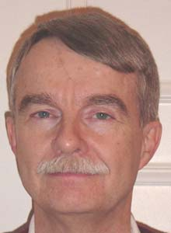

The JCSDA will continue 10 projects that were initiated in 2004 and 2005 at the level of $1 M. It is estimated that a total $ 1.8 M will be available for the FFO in FY06, leaving ~ $800K available to begin 6 - 8 new investigations. The JCSDA FFO is funded by NOAA, NASA, and DoD (through the NPOESS Integrated Program Office).
(Jim Yoe, NESDIS)

JCSDA Holiday Party

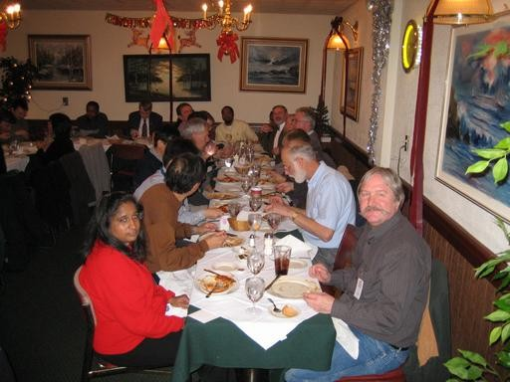

JCSDA staffers and guests enjoyed a Holiday get –together and luncheon at Mama Stella’s Restaurant on December 7.

Outlook for Next Quarter

Upcoming JCSDA Events:

Planning is underway for the Annual JCSDA Science Workshop to be held during the latter half of April, 2006 in the Washington, D.C. area. The precise dates, venue, and logistic details will be posted on the JCSDA Website as soon as the information is confirmed. The Workshop provides an opportunity for investigators to share the results of their efforts with one another and with the JCSDA Executive Team, and to receive guidance to make research gains suitable for operational implementation. All PIs receiving support via the FFO or the JSDI should plan to participate in the Workshop. Templates for presentations and summary reports will be distributed via e-mail and the Website before the Workshop. Other upcoming events include:

- • Science Steering Committee Meeting, May 2006
- • Management Oversight Board Meeting, May 2006
- • Advisory Board Meeting, June 2006

Upcoming JCSDA Seminars

2/16/06 | Monica Coakley | MIT | GOES-R
3/15/06 | Eugenia Kalnay | U. Maryland | Comparison of Local Ensemble Transform Kalman Filter and 3D-Var
4/19/06 | Jim Cummings | NRL | Ocean Data Assimilation at NRL

Suggestions for speakers and topics are always welcome: please send them to george.ohring@noaa.gov.

Please submit news items 2 weeks prior to the end of each quarter to george.ohring @noaa.gov



