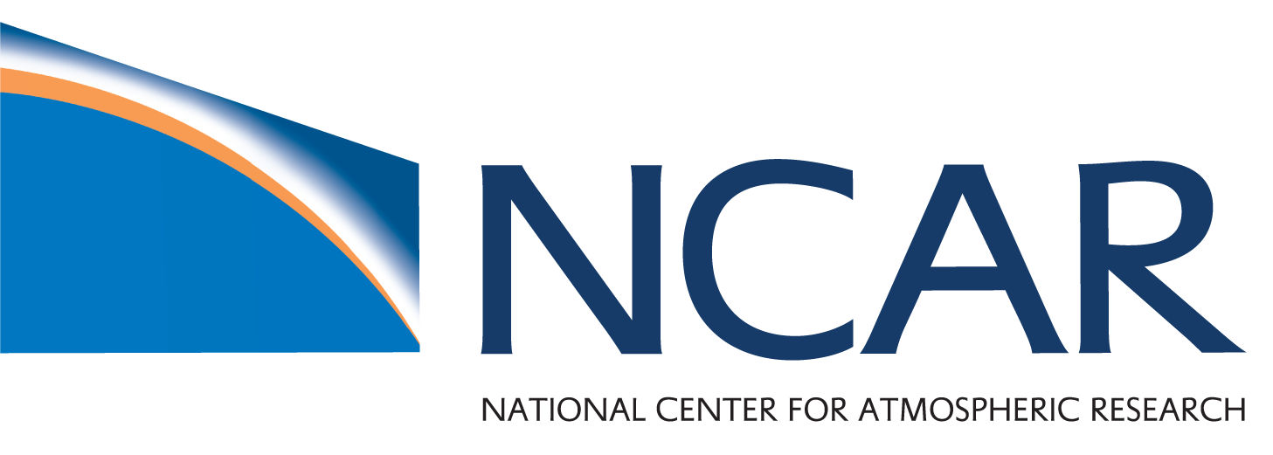

NCAR Fellows Association: A Private Sector Panel

Thursday, March 14th, 9:00 – 10:30 AM
NCAR FL1-EOL Atrium
1450 Mitchell Lane, Boulder, CO

Please join us for a panel with three scientists or engineers who work in the private sector to learn more about careers outside of academia for when you are teaching or if you ever want to look for work in that sector.

Below are descriptions of the panelists. Each panelist will spend five minutes describing their own career trajectory, and then we will have a Q & A session on things about what they enjoy or find challenging in their work, when and why they decided to go in this career direction, or how they went about it.

Luke Madaus

Jupiter Intelligence
www.linkedin.com/in/luke-madaus-57b0b234
luke.madaus@jupiterintel.com

Luke Madaus has a background in data assimilation and mesoscale numerical weather prediction, with undergraduate degrees from the University of Oklahoma and a masters and PhD in Atmospheric Science at the University of Washington. He is also a former ASP postdoctoral fellow at NCAR. Luke Madaus has worked at Jupiter Intelligence, a startup focused on predicting risk in a changing climate using AI and scientific models, since 2017. Jupiter provides data and analytics services to better predict and manage risks from weather and sea level rise, storm intensification and changing temperatures caused by medium- to long-term climate change. Luke Madaus works as a staff scientist and geospatial solutions engineer at Jupiter, designing and implementing end-to-end product suites that take the latest climate science and translate it to hyper-local impacts, tailored to customer needs. He is also in charge of recruitment for Jupiter's summer internship program and contributes to Jupiter's junior-level hiring and talent acquisition.

Aaron J Piña
AERIS Atmospheric Science and Engineering Solutions:
Innovative Products and Services for Aerospace, Defense, and Intelligence Applications
https://aerisllc.com/aaron-pina/
pina.aaron@gmail.com

Aaron’s research experience as a graduate student focused on atmospheric dispersion modeling, numerical modeling, mountain meteorology, agricultural ecosystems, land cover change impacts on regional climates, and social-ecological systems. For his Ph.D. research, Aaron co-developed and managed a meteorological early warning system for livestock producers in eastern Colorado to mitigate emissions that have deleterious impacts on mountain ecosystems. Aaron joined Aeris, a small-business start-up, as a Staff Scientist in January 2017. He currently works on projects with U.S. agencies, such as Departments of Defense and Energy, to develop technical tools that study the atmospheric transport and dispersion of chemical, biological, radiological, nuclear, and explosive material. He also helps prioritize business development strategies based on latest science and policy issues related to atmospheric transport, dispersion, deposition, ecosystem impacts, and human health impacts to ensure the use of the latest methodologies and technologies.

Sarah Woods
SPECinc: Innovation in Atmospheric Science Instrumentation
http://www.specinc.com/node/158
swoods@specinc.com

Dr. Sarah Woods is a Research Scientist at SPEC Inc. She received a B.S. with honors in Electrical Engineering from Colorado State University, and a Ph.D. in Applied Marine Physics from the Rosenstiel School of Marine and Atmospheric Science (RSMAS) at University of Miami. Following her graduate degree, she was awarded an ASEE Postdoctoral Research Fellowship with the U.S. Naval Research Lab (NRL) at Stennis Space Center to continue her research in ocean optics. Her oceanographic research has encompassed studies of ocean optics, turbulence, underwater imaging, and air-sea gas exchange. Following her postdoc, she extended her oceanic skillset to atmospheric studies to branch out into cloud physics. She now works as a research scientist for a company that develops instruments and conducts research specializing in cloud microphysics. This work involves outfitting various research aircraft, both manned and unmanned, with optical instrumentation that takes high resolution images and collects observations of the size, shape, concentration, and phase of cloud particles. She analyzes this data to yield insight into the microphysical processes governing the life cycle of various cloud types. Her research has involved laboratory and fieldwork and provides opportunity for collaboration with NASA, NOAA, NCAR, DOE, NRL, and other government and university research groups.

