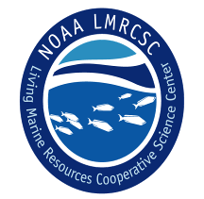
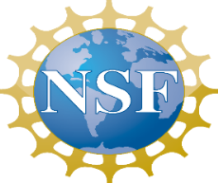
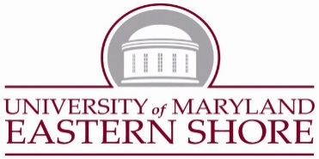
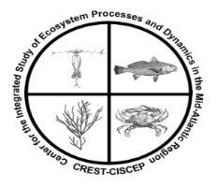

Graduate Research Assistantship Positions at the University of Maryland Eastern Shore (UMES), Department of Natural Sciences

NSF - CREST Center for the Integrated Study of Coastal Ecosystem Processes and Dynamics in the Mid-Atlantic Region

Graduate Research Assistantship Position Beginning in Spring 2017 or Fall 2017

We seek qualified candidates who are interested in enrolling in the University System of Maryland Marine, Estuarine and Environmental Science (MEES) M.S. or Ph.D. degree program to conduct research on any one of the following areas:

- Assessment and modelling of Vibrio spp. dynamics, and microbial community in water and blue crabs
- Food web dynamics in coastal lagoons
- Hydrodynamic modeling and exchange of water and other materials between coastal lagoons and the coastal ocean
Requirements:
- The Graduate Research Assistantships are available only for U.S. citizens, nationals or permanent residents.
- Minimum qualifications include a B.S. degree in marine biology, biology, zoology, environmental science or a related discipline.
- Excellent written and oral communication skills as well as interpersonal skills.
- The ability to conduct field work in coastal waters is required.

Stipend and tuition: The Assistantship will be for a maximum of three years for a M.S. student, and five years for a Ph.D. student, and covers stipend ($21,000 per annum) and tuition. The positions are dependent on the availability of funds. Interested candidates are requested to submit via email an application that includes a cover letter describing their research interests, a CV including cumulative GPA, and three letters of recommendation to: Dr. Paulinus Chigbu (pchigbu@umes.edu). Review of applications will begin immediately and continue until the positions are filled. You may call (410) 422-8181 if you have questions regarding the positions.

