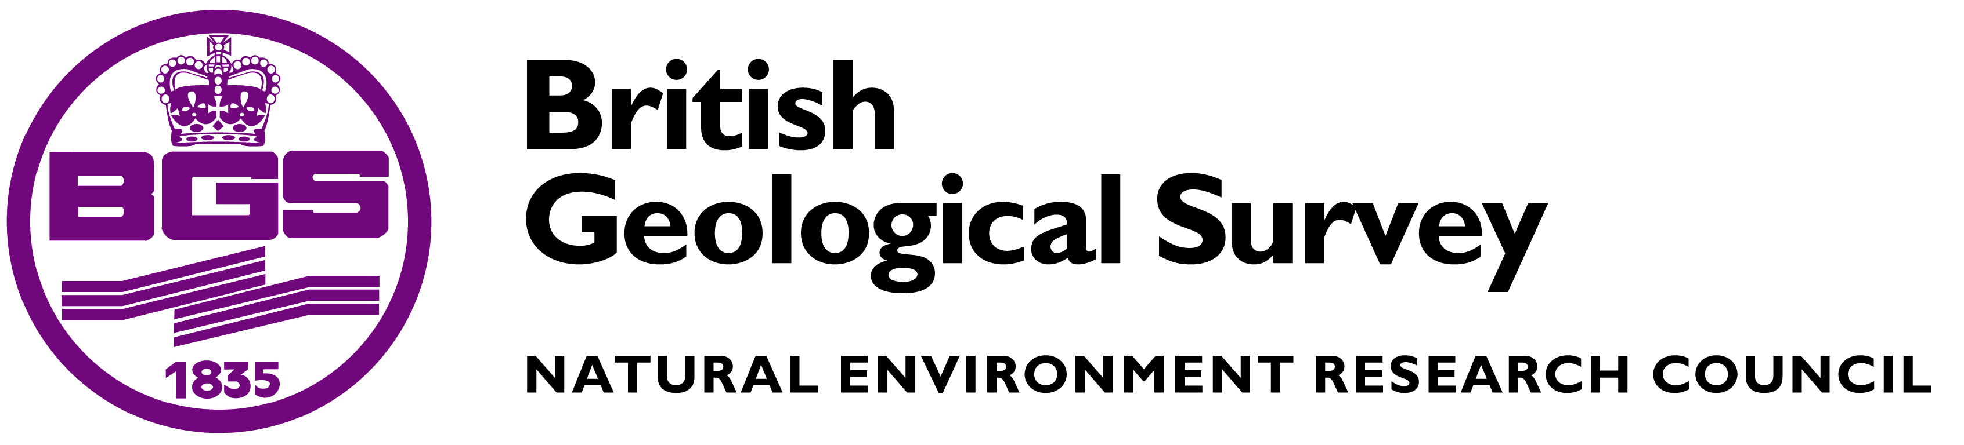

Senior Data Scientist

The British Geological Survey (BGS) is one of the world's leading and forward thinking geological science institutes with a focus on both public good science for government and geoscientific research to understand earth and environmental processes. A vacancy has arisen for a Senior Data Scientist at our headquarters in Keyworth.

Duties include;

• Utilise data (e.g. captured through the Energy Security and Innovation Observing System for the SubSurface (ESIOS)) to help develop data driven insights into the subsurface environment.
• Liaise with a variety of H2020 project leaders in BGS , team leaders and their external collaborators to ascertain how Data Science techniques could be applied to contribute to delivery of their scientific objectives (themes could include urban geoscience for resilient urban design, social sensors to gain better awareness of public perceptions of different geoscience activities e.g. Natural Hazards, energy projects).
• Develop a suite of prototypes or demonstration applications that showcase the value of applying data Science techniques to a variety of geoscience areas (in relation to above bullet point).
• Initiate investigative work into new technologies, engage with discussions on suitability and adoption.
• Develop the Data Science capabilities within BGS through leading Informatics strategy in this area and sharing knowledge, experience and expertise with others.
• Seek avenues for future funding for the Informatics Directorate (particularly with regard to Data Science) through commercial projects or collaborative partnerships in the Informatics/Geoscience area.
• Identify or bring techniques that have proved successful in scientific or other business domains and apply them to a geoscience (Earth/ Geological Science) setting.

This is advertised as a full time post but we will consider applications from those who require more flexible arrangements.

Starting salary for this permanent role is £35,222 per annum to £38,254+ per annum depending on qualifications and experience. Only candidates with exceptional skills, meeting both the essential and several of the desired criteria would be considered at the top level of this range.

Working hours will be 37 per week excluding lunch breaks. A generous benefits package is also offered, including a company pension scheme, childcare voucher scheme, 30 days annual leave plus 10.5 days public and privilege holidays.

Applications are managed by the RCUK Shared Services Centre; to apply for this post please visit our job board at http://www.topcareer.jobs/home/BritishGeologicalSurvey.aspx and submit your CV and covering letter. Applicants who would like to receive this advert in an alternative format (e.g. large print, Braille, audio or hard copy), or who are unable to apply online should contact us by telephone on 01793 867003, Please quote reference number IRC225589.

Closing date for receipt of applications is 24th July 2016.

The Natural Environment Research Council is an equal opportunities employer and welcomes applications from all sections of the community. People with disabilities and those from ethnic minorities are currently under-represented and their applications are particularly welcome. The British Geological Survey is an Investors in People organization and has achieved Bronze status for Athena Swan – a scheme that recognizes excellence in women's employment in science, technology, engineering, maths and medicine (STEMM) in UK higher education.
There is a guaranteed Interview Scheme for suitable candidates with disabilities.

NATURAL ENVIRONMENT RESEARCH COUNCIL

