JOB DESCRIPTION
 |  | 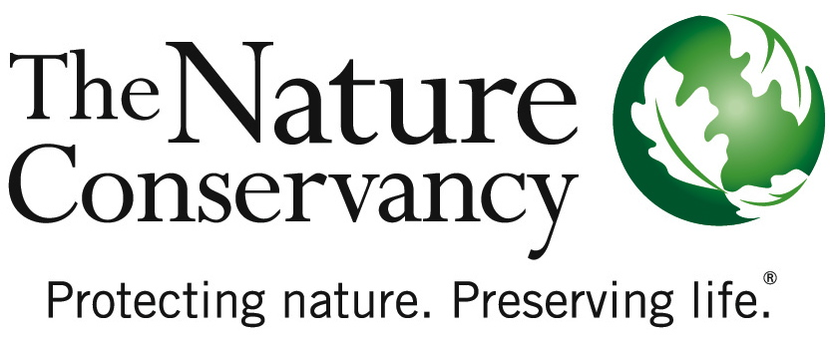
JOB TITLE | Lead Scientist-Soil Sciences
JOB ID | 44032
Location | US- negotiable
SUMMARY | The health of agricultural soils sits at a critical nexus between the environment and society. Soil management decisions made in coming years will strongly influence climate trajectories and climate adaptation potential in crop and pasture lands, and will directly affect crop and livestock yields and our ability to meet food, fiber, fuel and water demands without expanding the global agricultural footprint and further damaging the environment. The Nature Conservancy seeks a scientific thought leader with a proven record of success in soil sciences to drive a high-impact, global research agenda on improving soil health. S/he will lead development of this exciting new field within the Conservancy, testing and demonstrating work at scale across Conservancy and partner landscapes. Through a rigorous, global soil science research initiative, the Conservancy seeks to explore scientific evidence for the role of improved soil health as a component of natural climate solutions that mitigate a significant proportion of anticipated greenhouse gas emissions, a key to thriving soil biodiversity, and a critical input to agricultural production. As a member of the Global Lands team, the Lead Scientist will synthesize and create evidence addressing sustainable agriculture, including the role of improved soil management to cost effectively sequester and store carbon at scale. As a member of the Science Cabinet, a collaborative group of all Conservancy Lead Scientists, the Lead Scientist will contribute topical expertise to cross-cutting science issues for the organization, and represent the organization in science conferences, university partnerships, and high-level events around critical conservation issues.
ABOUT US | The Nature Conservancy is the leading conservation organization working to make a positive impact around the world in more than 35 countries, all 50 United States, and your backyard. Founded in 1951, the mission of The Nature Conservancy is to conserve the lands and waters on which all life depends. One of our core values is our commitment to diversity. Therefore we are committed to a globally diverse and culturally competent workforce. Visit www.nature.org/aboutus to learn more.  The Global Lands team operates at the intersection of global development and environmental challenges. We aim to meet increasing demands for energy resources, water supply and food production with low environmental impact, an in a mindset where nature is seen as a critical input to these key human needs.. We do this by engaging governments, the private sector and local communities to ensure that conservation is a critical outcome in economic development.  We have four inter-related areas of work: the first is focused on transforming how development occurs on ‘working’ lands, broadly including croplands, pasturelands and forests; the second is around influencing climate policy to include a much stronger recognition of the role of natural carbon storage in soils and vegetation; the third is to advance siting and mitigation practices where agricultural or energy development is occurring; and fourthly, to empower communities and indigenous peoples to steward natural resources where they live.  If you have a personal passion for conserving and protecting the natural world with a belief in The Nature Conservancy’s mission, then please apply to this position and learn more about the Conservancy.
ESSENTIAL  FUNCTIONS | The Lead Scientist will offer technical and science strategic leadership for the Conservancy’s Global Lands program on issues of improved crop and rangeland management including soil management, agriculture-soil-climate interactions, sustainable intensification, climate-smart agriculture, multi-functional landscapes, and food systems analysis and planning. S/he will drive efforts to establish TNC as a global leader in the application of soil sciences to conservation challenges including the global climate challenge. S/he conducts original research, publishes findings and communicates to diverse audiences to add to the evidence base for conservation strategies in support of TNC organizational goals.  The Lead Scientist will be an active collaborator with the Science Cabinet in the Office of the Chief Scientist – a collaborative group that brings top level thought leadership to the organization’s strategy leaders, establishes and advances critical science issues with the external academic and practitioner communities, and takes on joint research to address pressing trans-disciplinary issues in conservation.
RESPONSIBILITIES  & SCOPE | - Fosters risk taking and innovation to strengthen the use of soil sciences within the organization.  - Leads project teams and/or staff in support of a major science initiative or project.  - Places special emphasis on research and synthesis that advances the evidence base for understanding effectiveness of major conservation strategies in improving biodiversity and human well-being.  - Communicates findings and best practices in high-level international forums and peer reviewed publications, and cultivates an external presence in coordination with TNC Communications team as an expert and leader in relevant disciplines  - Provides critical, evidence-based thought leadership, advising on and influencing the creation and execution of major strategies for the Global Lands Program.  - Leads efforts to translate findings and best available science into regionally or sectorally-appropriate guidelines, tools, and/or best practice for the organization and the broader conservation community  - Enlists academic scientists in research on challenges of interest to the organization  - Identifies, cultivates and solicits major donors and grant opportunities in support of program activities.  - Plans, organizes and directs project programs.  - Develops work plans and project budgets.  - Travels 30% or more globally.
MINIMUM QUALIFICATIONS | - PhD degree in related scientific field (including soil microbiology, agronomy, biogeochemistry, climatology, pedology, edaphology, rangeland management), plus 10 years related experience in the design, execution and communication of use-inspired soil science.  - Post-doctoral experience.  - Supervisory experience, including motivating, leading, setting objectives and managing performance.  - Established connections and/or collaborations with prominent soil scientific research and practitioner groups and individuals  - Expert knowledge of current and evolving trends in relevant discipline.  - Extensive record of premier publications in top-notch peer reviewed scientific journals.  - Experience translating science across traditional disciplinary boundaries and into pragmatic conservation and/or natural resource management decisions.  - Fundraising experience (with foundations, government agencies, and individuals) for broad programs and projects.  - Experience creating or functioning within university partnerships.  - Experience with networking in the scientific community.  - Experience working and communicating with a wide range of people.  - Experience with decision making with legal, financial and reputational results and consequences.
PREFFERED  QUALIFICATIONS | - Experience in the agriculture and rangeland sectors, with particular emphasis on interactions between management, soil health, productivity and climate change, and familiarity with these sectors’ particular conservation challenges and opportunities.  - Experience in identifying, cultivating and soliciting major donors  - Ability to resolve large-scale, complex problems through systematic, rigorous studies.  - Ability to propose, implement and manage short and long term programmatic goals.  - Ability to produce scientific research that balances data and resource limitations with rigor and credibility  - Ability to participate in the formulation of broad, strategic policies.  - Ability to manage and guide projects and project teams.  - Ability to deal effectively and diplomatically with all levels of management and staff.  - Proven negotiation and persuasion skills.

ORGANIZATIONAL COMPETENCIES | Accountability for Outcomes Pushes for excellence. Establishes challenging goals for self and others to drive performance in support of the Conservancy’s mission. Rewards behavior that achieves these standards and is aligned with the organization’s mission/ values. Takes action to address performance problems in a timely and appropriate manner.  Builds Organizational Capability Builds or adapts organizational structures to accomplish the mission and to improve performance. This includes reorganizing organizational systems, structures, processes, procedures, communication channels or reporting relationships. With the Conservancy’s strategic filter in mind, determines who can contribute, gets the right people involved, and builds bench strength for the future.  Collaboration & Teamwork Shows a willingness to put the needs and goals of a global organization before personal/local/departmental needs. Works with others across organizational boundaries. Makes decisions, sets priorities, and allocates resources to help the organization as a whole achieve results.  Courage & Decisiveness Makes decisions and stands by them. Makes timely decisions even under pressure and when lacking complete information. Has the courage to modify decisions and admit why and how they were wrong.  Develops Strategic Partnerships Improves position of the Conservancy with key stakeholders and constituents. Builds broad, global networks with internal and external stakeholders (e.g., boards, NGOs, government agencies, donors, other conservancies) to raise awareness of conservation issues and further organizational goals.  Focused Innovation Personally demonstrates innovative thinking and encourages this behavior in others. Is willing to take calculated risks within organizational parameters in order to achieve tangible results that advance the strategic agenda of the Conservancy. Achieves results by generating and encouraging the development of imaginative, novel, or original ideas and solutions that are consistent with TNC strategy.  Influences for Results Achieves results by persuading, convincing, or influencing others. Adapts approach to the individual or group and knows how and when to use complex influence strategies. Uses success stories and passion for the mission to generate enthusiasm and support.  Strategic Initiative The ability to identify trends and opportunities for the Conservancy to achieve effective global conservation. Develops strategies and plans aligned with the mission. Understands both the immediate and long-term implications of each decision by looking beyond their local environment.  Visionary Leadership Inspires team to meet challenges and implement the strategy. Includes communicating an inspiring vision and generating clarity, commitment and passion for the mission.
HOW to APPLY | To apply to position 44032 visit www.nature.org/careers and submit resume and cover letter as one document. Application deadline May 8, 2016.
This description is not designed to be a complete list of all duties and responsibilities required for this job.

