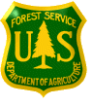
OUTREACH NOTICE

Soil Scientist
GS-0470-05/07/09
Salary Range: $31,628 – $62,297
USDA Forest Service
Southwestern Region
Terrestrial Ecological Unit Inventory

Coronado National Forest

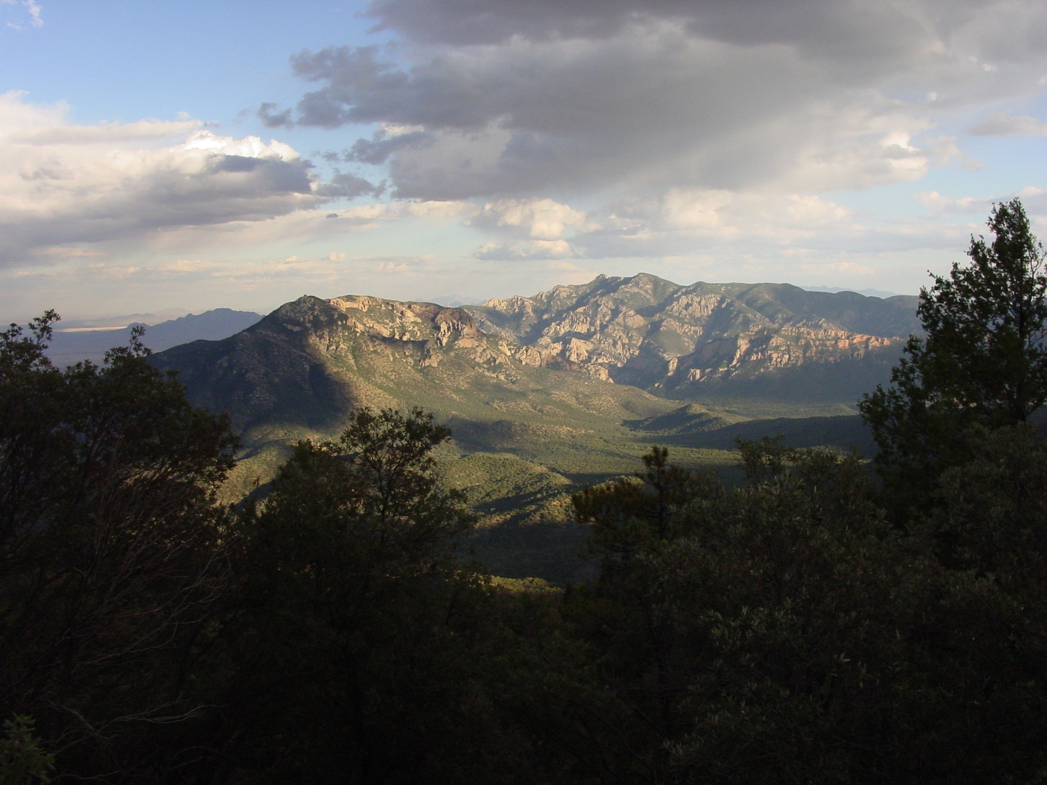

The Southwestern Regional Office will soon be advertising a GS-0470-05/07/09 permanent, full-time soil scientist positions within the Ecosystem Analysis and Planning/Watershed and Air Staff. This position is assigned to the Terrestrial Ecological Unit Inventory team co-located at the Coronado National Forest Supervisor’s Office in Tucson, AZ. Please note: The purpose of this Outreach Notice is to inform interested applicants of the upcoming opportunity and evaluate their responses to help determine the appropriate recruitment method (e.g. target grade(s), service-wide/region-wide/government-wide, DEMO, Pathways, Recent Graduates) and area of consideration that will generate a diverse and highly qualified applicant pool for the position.

To express interest in this position, please complete the attached Outreach Response Form and return by October 31st, 2014.

The Position
The primary purpose of this position is to participate in the completion of the Terrestrial Ecological Unit inventory of the Coronado National Forest. This is a field going position with major duties associated with describing, classifying and mapping climate, soils, vegetation, geology, and geomorphology. We are looking for an individual who has:

- Skill with aerial photo interpretation, geospatial applications, and other remote sensing techniques.
- Skill in the use of software applications including ESRI ArcMap, GPS applications, word processing, spreadsheets, and databases.
- Skill in describing soil profiles, identifying plants and describing plant communities, interpret geological and geomorphic processes.
- Physical ability to traverse and work in rough, rugged terrain under challenging weather conditions.
- Ability to operate 4-wheel drive vehicles, truck mounted backhoe, and ATVs.
- Good organizational and communication skills.
- Good leadership and interpersonal skills to work in a team-oriented environment.
- Ability to work safely and independently.
- Ability to describe, classify, map, and interpret complex ecosystems.
- Ability to multi-task under short turn-a-round timeframes.

For information about the position please contact:
Andy Casillas, Supervisory Soil Scientist , markcasillas@fs.fed.us or call 602-225-5207

The Tucson Community:

Tucson is a wonderful place to experience the culture and traditions of Southern Arizona. Education, real estate, shopping and entertainment opportunities are comparable with other major US cities of similar size. Approximately 850,000 people live within the Tucson city limits, and the greater Tucson area is well over 1 million people. Tucson celebrates a diversity of cultures, architecture, and peoples. It is recognized as a premier health services center for the Southwest, the astronomy center of the world, home of a premier research institution - University of Arizona, and a popular tourist destination. Tucson's rich cultural heritage centers on a unique blend of Native American, Spanish, Mexican, and Anglo-American influences. Blessed with the natural beauty of the Sonoran Desert and an unsurpassed climate of 300 sunny days a year, Tucsonans embrace a unique lifestyle and are committed to preserving that quality of life.

Tucson is also one of the oldest towns in the United States. It has been continuously settled for over 12,000 years. Today’s city was originally an Indian village called Schookson, meaning “spring at the foot of a black mountain”. In 1775 the Tucson Presidio was established, and August 20th, 1775, is considered Tucson's birthday. Spanish settlers arrived in the area in 1776, and Tucson officially became part of the United States with the Gadsden Purchase of 1854. Tucson served as capital of the Arizona Territory from 1867 to 1877.
Additional information about Tucson, AZ, can be found at these websites:

www.visittucson.org/visitor/about/relocation/
http://cms3.tucsonaz.gov/
www.city-data.com/city/Tucson-Arizona.html

Climate:

Tucson's climate varies from the 2,400-foot Sonoran Desert Basin to the 9,100-foot forests of the Santa Catalina Mountains. The city's dry desert air and winter sunshine make it a popular health and winter resort. More information on climate and links can be found at:

http://wc.pima.edu/~bfiero/tucsonecology/climate/climate_home.htm

Education:

Tucson Unified School District (TUSD) is the second-largest district in Arizona and the 52nd-largest district in the United States. The district operates 74 elementary schools, 20 middle schools, 10 high schools, and 9 alternative programs. To meet the needs of 63,000 children, over 8,000 regular employees work for TUSD. The University of Arizona main campus is near downtown Tucson, Pima Community College provides six campuses distributed across the city, and independent institutions such as the University of Phoenix and ITT Technical Institute offer flexible education in business and technology applications.

Housing:

Government provided housing and day care facilities are not available. A wide variety of housing options exist in Tucson and adjacent communities with home prices ranging from $150,000-$550,000 and more. Median new home prices are about $235,000 and median rent is $658, but can range significantly higher depending on location. Census bureau data for housing can be viewed at:

http://www.infoplease.com/us/census/data/arizona/tucson/housing.html

Churches:

Churches of most denominations can be found within a 10-mile radius, including, but not limited to: Assembly of God, Baptist, Catholic, Church of Christ, Church of Jesus Christ of Latter-Day Saints, Episcopal, Jehovah’s Witness, Lutheran, Methodist, Nazarene, Pentecostal, Presbyterian, Seventh-Day Adventist and Non-Denominational. A complete listing of churches and a search engine can be found at:

http://www.usachurch.com/arizona/tucson/churches.htm

Information about the Coronado National Forest can be obtained from the website http://www.fs.usda.gov/coronado/ .
The position will be advertised through the USAJOBS website (http://www.usajobs.gov/).

OUTREACH RESPONSE FORM

If you are interested in this position, please complete this form and email it to Andy Casillas (markcasillas@fs.fed.us). Forms may also be mailed to Andy Casillas, Tonto National Forest, 2324 E. McDowell Road, Phoenix, AZ 85006 or FAX #602-225-5295. Please respond by October 31, 2014. You will automatically receive notice of the advertisement if you return the outreach form.

I am interested in the following position: Soil Scientist, GS-0470-05/07/09

Location: Region 3, Southwestern Region, Terrestrial Ecological Unit Invertor, Coronado National Forest, Tucson, AZ

PERSONAL INFORMATION:

Name: |  | Date:

Address:

Email Address:

Phone:

Are you currently a Federal employee? | YES: |  | NO:

IF YES: Current Agency and location:

Current title/series/grade:

Current Type of Appointment: | Permanent |  | Term |  | Temporary |  | Reinstatement Eligble

If you are not a current permanent employee (career or career conditional), are you eligible for appointment under any of the following special authorities?
Person with Disabilities
Veterans Readjustment
Former Peace Corps Volunteer
Disabled Veteran with 30% Compensable Disability
Pathways Students and Recent Graduates https://www.usajobs.gov/StudentsAndGrads
Veterans Employment Opportunities Act of 1998
Other, please describe:
Applicants may use this space to identify special qualifications, interests, needs or provide other information.

Thank you for your interest in our vacancy!


USDA Non-Discrimination Statement

"The U.S. Department of Agriculture (USDA) prohibits discrimination in all its programs and activities on the basis of race, color, national origin, age, disability, and where applicable, sex, marital status, familial status, parental status, religion, sexual orientation, genetic information, political beliefs, reprisal, or because all or part of an individual's income is derived from any public assistance program. (Not all prohibited bases apply to all programs.) Persons with disabilities who require alternative means for communication of program information (Braille, large print, audiotape, etc.) should contact USDA's TARGET Center at (202) 720-2600 (voice and TDD). To file a complaint of discrimination, write to USDA, Director, Office of Civil Rights, 1400 Independence Avenue, S.W., Washington, DC 20250-9410, or call (800) 795-3272 (voice) or (202) 720-6382 (TDD). USDA is an equal opportunity provider and employer."

