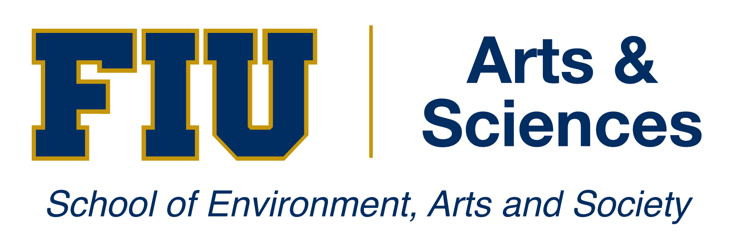

Instructor Position – Agroecology at Florida International University

The Agroecology Program of Earth & Environment Department invites applications for an instructor in the areas of production Agriculture/Horticulture, to begin in Fall 2014. We seek an outstanding candidate with teaching focused on horticulture, agronomy or general cropping systems in sub-tropical regions with a strong interest in 21st century agricultural practices and technology. The successful candidate is expected to develop and teach two regular and two short courses per semester, mentor students, and help to secure educational, research, and outreach grants.

Florida International University (FIU) is one of the Hispanic-Serving Agricultural College and Universities (HSACU), a new designation received since April 2012. The vibrant Agroecology Program started in 2005 with a significant funding support from the United States Department of Agriculture-National Institute of Food and Agriculture. This has become one of the signature programs in College of Arts & Sciences-School of Environment, Arts, & Society. Over the years, the Program has received support from USDA Hispanic Serving Institutions, Multicultural Scholarship Program, International Science Education Program, and National Needs Fellows Program of over $6 million. The program has developed strong collaborations with high schools, even middle schools, Fairchild Tropical Botanical Garden, USDA-ARS Sub-Tropical Horticulture Research Station, The DuMond Conservatory – Monkey Jungle/Possum Trot, and the University of Florida – Tropical Research & Education Center. We are rapidly expanding our program in Redlands area of Homestead with research, teaching, and outreach facilities. The facility is located in close proximity to USDA-ARS Subtropical Horticulture Research station and UF’s Tropical Research and Education Center to interact and develop strong collaborations in research, teaching, and outreach.

A Ph.D. in horticulture, agronomy, crop sciences, sustainable agriculture or related disciplines is required at the time of appointment. For more information contact Dr. Krishnaswamy Jayachandran at jayachan@fiu.edu or visit http://casgroup.fiu.edu/earthenvironment/. Applications should be made online through the http://careers.fiu.edu (job id number 507004) including: (a) curriculum vitae, (b) statements of teaching and research interests, and (c) contact information for at least three references. Applications will be reviewed beginning February 21, 2014. The search will remain open until the position is filled. FIU is a multi-campus public research university located in Miami, a vibrant, international city. FIU offers more than 180 baccalaureate, masters, professional, and doctoral degree programs to over 50,000 students. As one of South Florida’s anchor institutions, FIU is worlds ahead in its local and global engagement, and is committed to finding solutions to the most challenging problems of our times. FIU is a member of the State University System of Florida and is an Equal Opportunity, Equal Access, Affirmative Action Employer.

